AUTOCAD AND SOLIDWORKS
FOR
MECHANICAL ENGINEERS

A CERTIFICATE COURSE CONDUCTED
BY

THE SURE Trust
Skill Upgradation for Rural-youth Empowerment – Trust
https://suretrustforruralyouth.com/
Course Training Attended
By
BOGISETTY DHANUSH KUMAR
MARCH 2026 – SEPTEMBER 2026


DECLARATION
This is to certify that Mr. BOGISETTY DHANUSH KUMAR has successfully completed the four months training given in “AutoCAD and Solid Works for Mechanical Engineering” by SURE Trust during the period from March 2026 to September 2026.

Mr. Mairala Chinnarao
Trainer
AUTO CAD
SURE Trust




Prof.Ch. Radha Kumari Mrs.Vandana Nagesh
Executive Director & Founder, Director & Co-Founder,
SURE Trust SURE Trust

TABLE OF CONTENTS

- The SURE Trust
2 . Course Content
3. Conduct of the Course
- Student byelaws
- Written Tests
- Assignments
4. Student Feed back
5. Uniqueness of the Course according to student
6. Concluding Remarks

About the SURE Trust

Introduction to the SURE Trust
The SURE Trust is born to enhance the employability of educated unemployed rural youth. It is observed that there is a wide gap between the skills acquired by students from the academic institutions and the skills required by the industry to employ them. Employability enhancement is done through giving one on one training in emerging technologies, completely through online mode . The mission of the SURE Trust is to bridge the gap between the skills acquired and the skills required by training them in the most emerging technologies such as Autocad & Solidworks, Python Program, Machine Learning (ML), Deep Learning (DL), Data Science & Data Analytics, Block chain Technology, Robotic Process Automation (RPA), and Project Management and twenty other essential and high in demand Courses ,that will enhance their employability. After completion of four months training in the course, the trainees will get live projects from industries as internship activity to get experience in applying to real time situation what they have learnt during the course. These projects will give them hands on experience which is much sought after by the prospective industry employing them. Currently students from all over India are enrolling for various courses offered by the SURE Trust. The SURE Trust offers every course free of cost with no financial burden of any kind to students. This initiative is purely a service-oriented one aiming to guide the rural youth who are educated but unemployed due to lack of upgradation in their skill sets. The birth of SURE Trust is a God given boon to rural youth who could reach great heights either in employment or in entrepreneurship once they receive the training offered followed by the company internship. Many companies are coming forward to join their hands with us by offering internship projects to hand hold and lead the rural youth in their career settlement.

Vision of the SURE Trust
The vision of the SURE Trust is to enhance the employability of educated unemployed youth, particularly living in rural areas, through skill upgradation, with no cost to the students.

Mission of the SURE Trust
The mission is to bridge the gap between the skills acquired in the academic institutions and the skills required in industries as a pre-condition for employment.

Functioning of the SURE Trust

There are three dedicated, committed, and hard-working women on the board of management of the SURE Trust who will look into the various administrative and other matters relating to the enrolment of students, organizing trainers, entering into agreements with companies for getting live projects to students as internship programs, and so on.

All the three women on the board are all the alumni from Sri Sathya Sai Institute of Higher Learning, Anantapur Campus, deemed to be a University. The women board is supported by five eminent advisories who are from different walks of life and have made outstanding mark in career in their respective fields. For more details about SURE Trust please visit the website www.suretrustforruralyouth.com.

2. Course Content

The SURE Trust conducts a five months training for every course on a uniform basis. A session spanning across one to one & half hour is taken by the trainers for every major course. Sessions are conducted to complete the predesigned course structure within the fixed time period. Course content is designed to suit the current requirement of the Industry and validated by the industry experts. The course content of all these courses is so dynamic that any changed condition noticed in the industry will automatically get reflected in the content of the respective course . As the course content is dynamic, the Following is the course content of the current course in Data Science and Data Analytics:

AUTOCAD & SOLIDWORKS FOR MECHANICAL ENGINEERS

Objective:

The objective of this course is to train mechanical engineering students in the basic design software.
Course content:
Module 1. Autocad:
AutoCAD is a widely used software application that allows engineers to draw error-free designs. As such, its functions and
features must be understood properly by aspiring engineering students. The main topics covered are:
• Introduction to AutoCAD
• Getting started with toolsets generating design drawings with CAD
• Drafting styles and standards
• Annotation units and conversion methods
• Clear and error-free drawings

Module 2. Solidworks:
SolidWorks is a solid modeling computer-aided design (CAD) and computer-aided engineering (CAE) application published
by Dassault Systems. The topics covered are:
• Introduction
• Sketch and Various Sketch Tools in SolidWorks
• 3D Part Modelling Using SolidWorks Features
• SolidWorks Assembly and Its different Features
• Sheet metal, Weldments
• Basics of SolidWorks Rendering
• Drafting using SolidWorks Drawing

3.Conduct of the course
- Modalities for the conduct of all the courses are fixed by the SURE Trust which are uniformly followed across the courses.

  - Mode of Training --- Online
  - Period of Training --- Six months
  - Sessions per week --- 5-6
  - Length of the session --- 1 to 1:30 hours
  - Tests to be taken --- 2 per month
  - Assignments --- 3 per month
  - Last 15 days --- Final practice and preparing the course report

- Student byelaws:

- Students enrolling for the courses under SURE Trust are strictly required to follow the following byelaws set for them.

Byelaws for students to become eligible for certificate at the end of the course

- Minimum Attendance:
- Every student must put in a minimum of 85% attendance in attending the classes for getting the eligibility to receive the certificates.

- Two written tests are to be taken in each month:
Since the objective of the certification program is to turn out well qualified students from the respective courses, minimum two written tests are to be taken in each month for each course to ensure that the students are pulled along the expected line of standard.

- Assignment submissions:
Ten exercises constituting one assignment for every two to three new functions/topics taught, resulting in minimum seven such assignments are to be submitted during the four months period.

- Preparing the final course report in the prescribed format:
During the last fifteen days in the six month, students many be asked to consolidate and compile all the assignments submitted in a word document along with the other chapters which will constitute a course report for each student. This report will be the unique contribution a student carries from the trust to show case the rigorous training he/she received during the four months period. Besides the report will stand as a testimony for the detailed learning a student has acquired in the chosen area. This will facilitate the industry in handpicking the required student for the job.

- External Viva-voce:
Every student has to successfully clear the external viva- voce arranged in their respective course.

- KYC norms:
Each student wishing to enroll for the course must submit a written letter saying that he/she will not drop from the course until its completion, which will also be signed by father / mother besides the student himself / herself.
- Attend the full class:

All the students are expected to attend each class for full duration. Some students are observed moving out of classes after logging in which does not go well with the learning objective of students.

- Ensure discipline in the group:
All the students are advised strictly to follow group etiquette and restrain from posting in the group any unethical messages or teasing messages or personal interactive messages. This group is purely created for academic purpose and hence only academic interactions should go on.

AutoCad & SolidWorks

The course is taught to the students as per the syllabus prescribed and as per the course modalities keeping in mind the bylaws set for them. Periodical tests are conducted to assess the understanding of the students in the course. Assignments are given to ensure that students gain versality in the designing. The assignments of the student are given below. These assignments which are done with high creativity and out of box thinking not only reflect the student’s innovativeness but also constitute solved exercises in the Various designs for the fresh learners to practice and gain confidence. The assignments are listed below in the order of their conducting during the course.

AutoCAD is a CAD program mainly used for architectural and construction designs, civil and structural engineering. On the other hand, SolidWorks is mainly used for mechanical parts and assembly design, technology designing, and automotive and aerospace designing.

Although AutoCAD and SolidWorks are computer-aided design software, their features differ greatly. Both have tools for 3D drawing but different aims. In AutoCAD, an object’s projected view can be drawn, but in SolidWorks, a sketch is created, which can be further made into a 3D model. 3D modeling features are more dominant in SolidWorks as compared to AutoCAD. In AutoCAD, the toolset is pretty much hidden.
ASSIGNMENTS
Assingment 1 :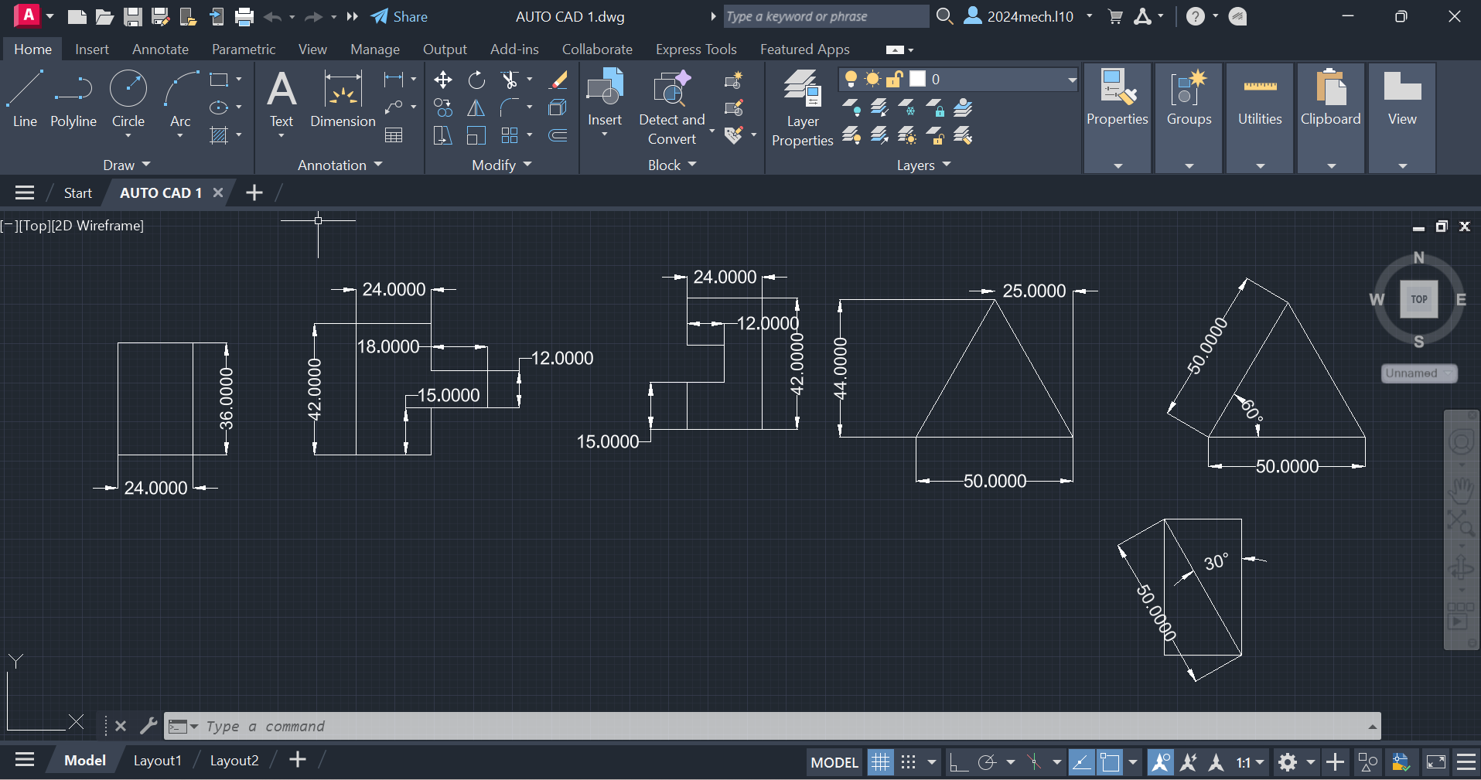

Procedure :

- First of all open autocad software in the laptop or in desktop .
- After opening, click on new the above page will appear in screen.
- If you don’t need grapical page click on ‘F7’ the grapical page will disappear in screen.
- After that press on letter ‘L’ for line command or you can directly click on line command which will be available in command box.
- Using line command draw the diagram with required dimensions.
- use the ‘trim’ and ‘arc’ commands, where it is needed.
- change the dimensions and units by clicking letters ‘Dim’ for ‘Dimensions’ and ‘U’ for ‘Units’ after clicking change the units.
- After drawing the diagram save it in laptop or in desktop.
Assingment 2 :
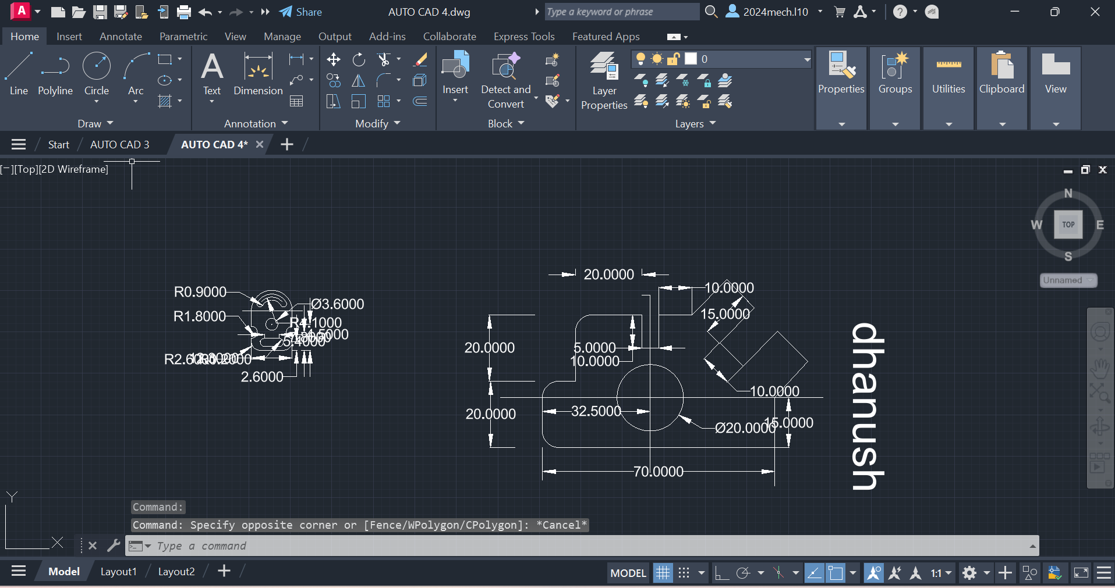

Procedure :

- First of all open autocad software in the laptop or in desktop .
- After opening, click on new the above page will appear in screen.
- If you don’t need grapical page click on ‘F7’ the grapical page will disappear in screen.
- After that press on letter ‘L’ for line command or you can directly click on line command which will be available in command box.
- Using line command draw the diagram with required dimensions.
- use the circle,trim and arc commands, where it is needed.
- change the dimensions and units by clicking letters ‘Dim’ for ‘Dimensions’ and ‘U’ for ‘Units’ after clicking change the units.
- After drawing the diagram save it in laptop or in desktop.

Assignment 3 :
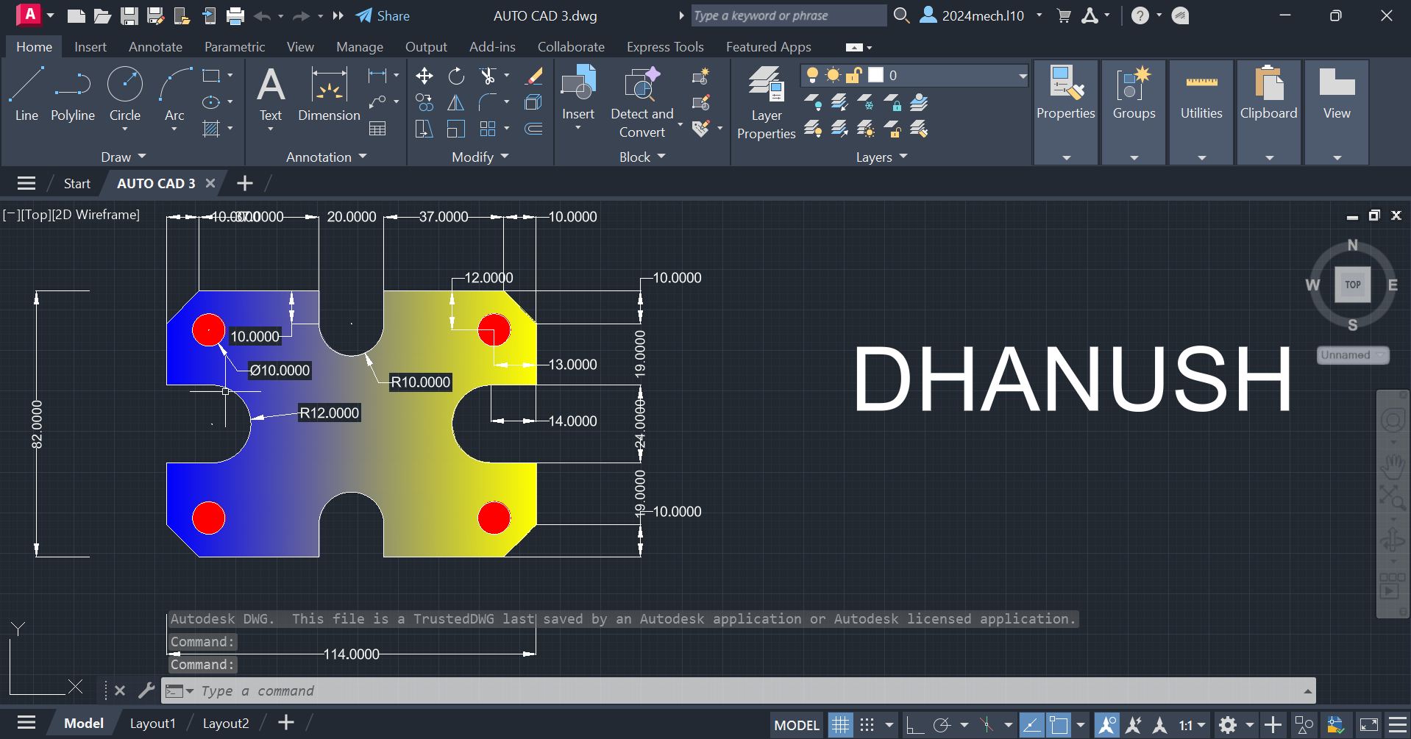

Procedure :

- First of all open autocad software in the laptop or in desktop .
- After opening, click on new the above page will appear in screen.
- If you don’t need grapical page click on ‘F7’ the grapical page will disappear in screen.
- After that press on letter ‘L’ for line command or you can directly click on line command which will be available in command box.
- Using line command draw the diagram with required dimensions.
- use the circle,trim and arc commands, where it is needed.
- change the dimensions and units by clicking letters ‘Dim’ for ‘Dimensions’ and ‘U’ for ‘Units’ after clicking change the units.
- After drawing the diagram save it in laptop or in desktop.

Assignment 4 :
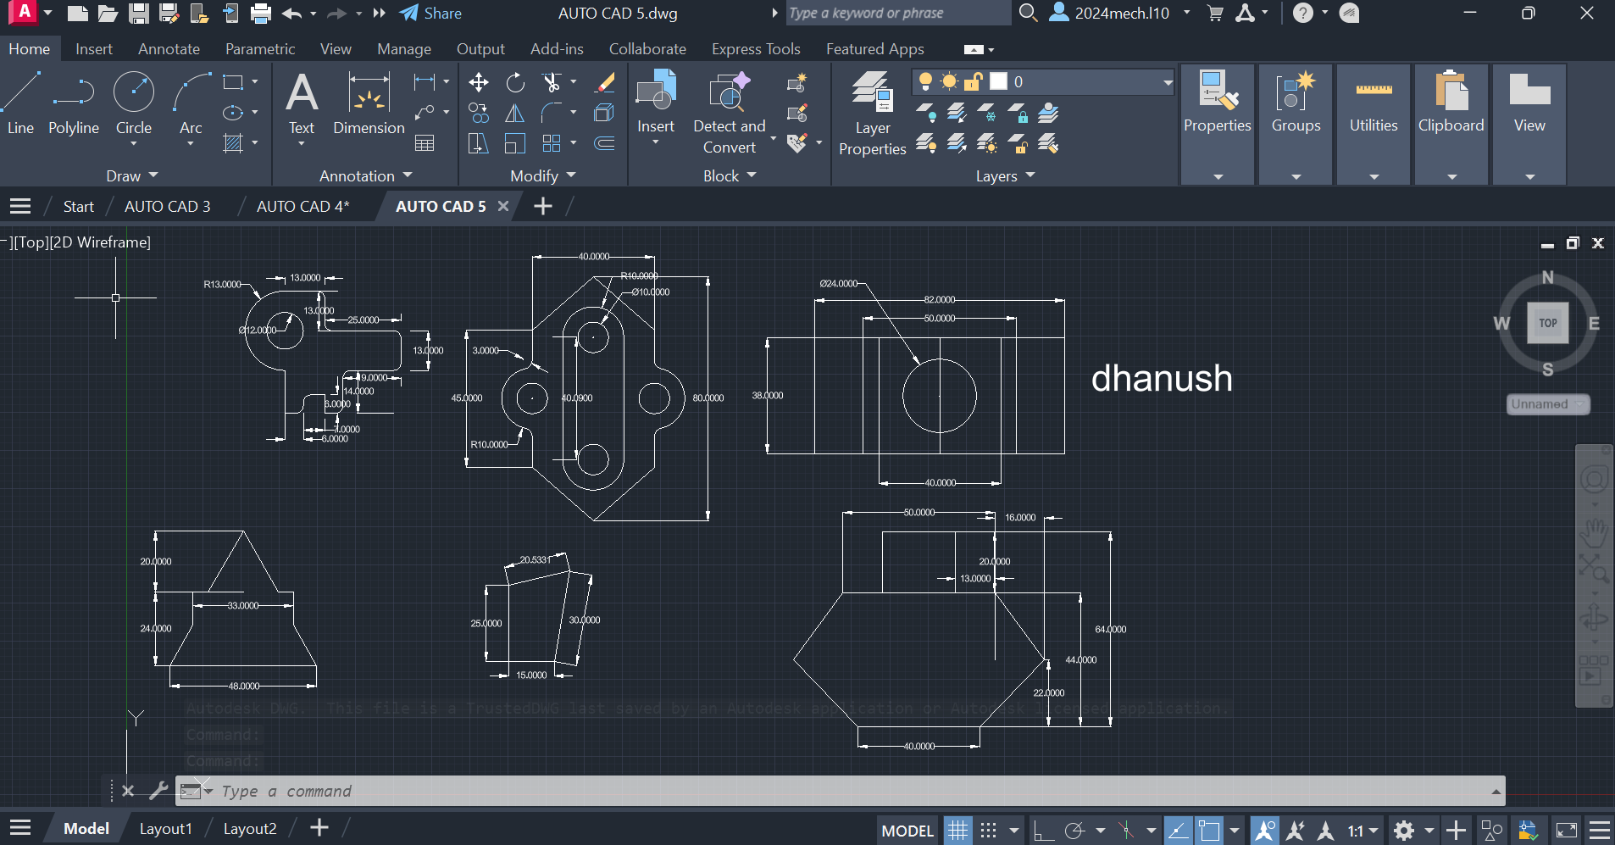

Procedure :

- First of all open autocad software in the laptop or in desktop .
- After opening, click on new the above page will appear in screen.
- If you don’t need grapical page click on ‘F7’ the grapical page will disappear in screen.
- After that press on letter ‘L’ for line command or you can directly click on line command which will be available in command box.
- Using line command draw the diagram with required dimensions.
- use the circle,trim and arc commands, where it is needed.
- change the dimensions and units by clicking letters ‘Dim’ for ‘Dimensions’ and ‘U’ for ‘Units’ after clicking change the units.
- After drawing the diagram save it in laptop or in desktop.

Assignment 5 :
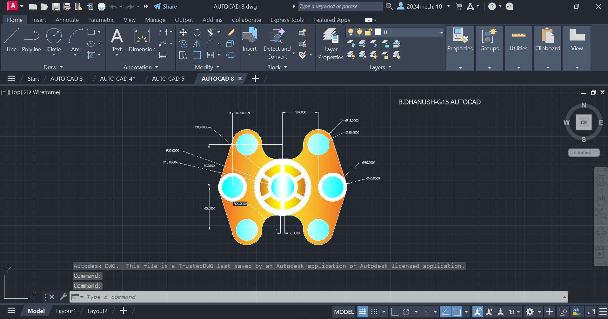

Procedure :

- First of all open autocad software in the laptop or in desktop .
- After opening, click on new the above page will appear in screen.
- If you don’t need grapical page click on ‘F7’ the grapical page will disappear in screen.
- After that press on letter ‘L’ for line command or you can directly click on line command which will be available in command box.
- Using line command draw the diagram with required dimensions.
- use the circle,trim and arc commands, where it is needed.
- change the dimensions and units by clicking letters ‘Dim’ for ‘Dimensions’ and ‘U’ for ‘Units’ after clicking change the units.
- After drawing the diagram save it in laptop or in desktop.

Assignment 6 :
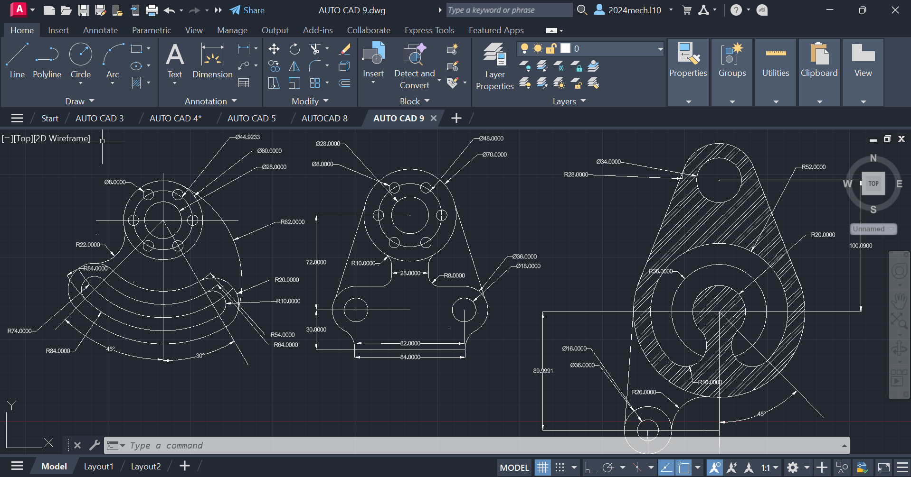

Procedure :

- First of all open autocad software in the laptop or in desktop .
- After opening, click on new the above page will appear in screen.
- If you don’t need grapical page click on ‘F7’ the grapical page will disappear in screen.
- After that press on letter ‘L’ for line command or you can directly click on line command which will be available in command box.
- Using line command draw the diagram with required dimensions.
- use the circle,trim and arc commands, where it is needed.
- change the dimensions and units by clicking letters ‘Dim’ for ‘Dimensions’ and ‘U’ for ‘Units’ after clicking change the units.
- After drawing the diagram save it in laptop or in desktop.

Assignment 7 :

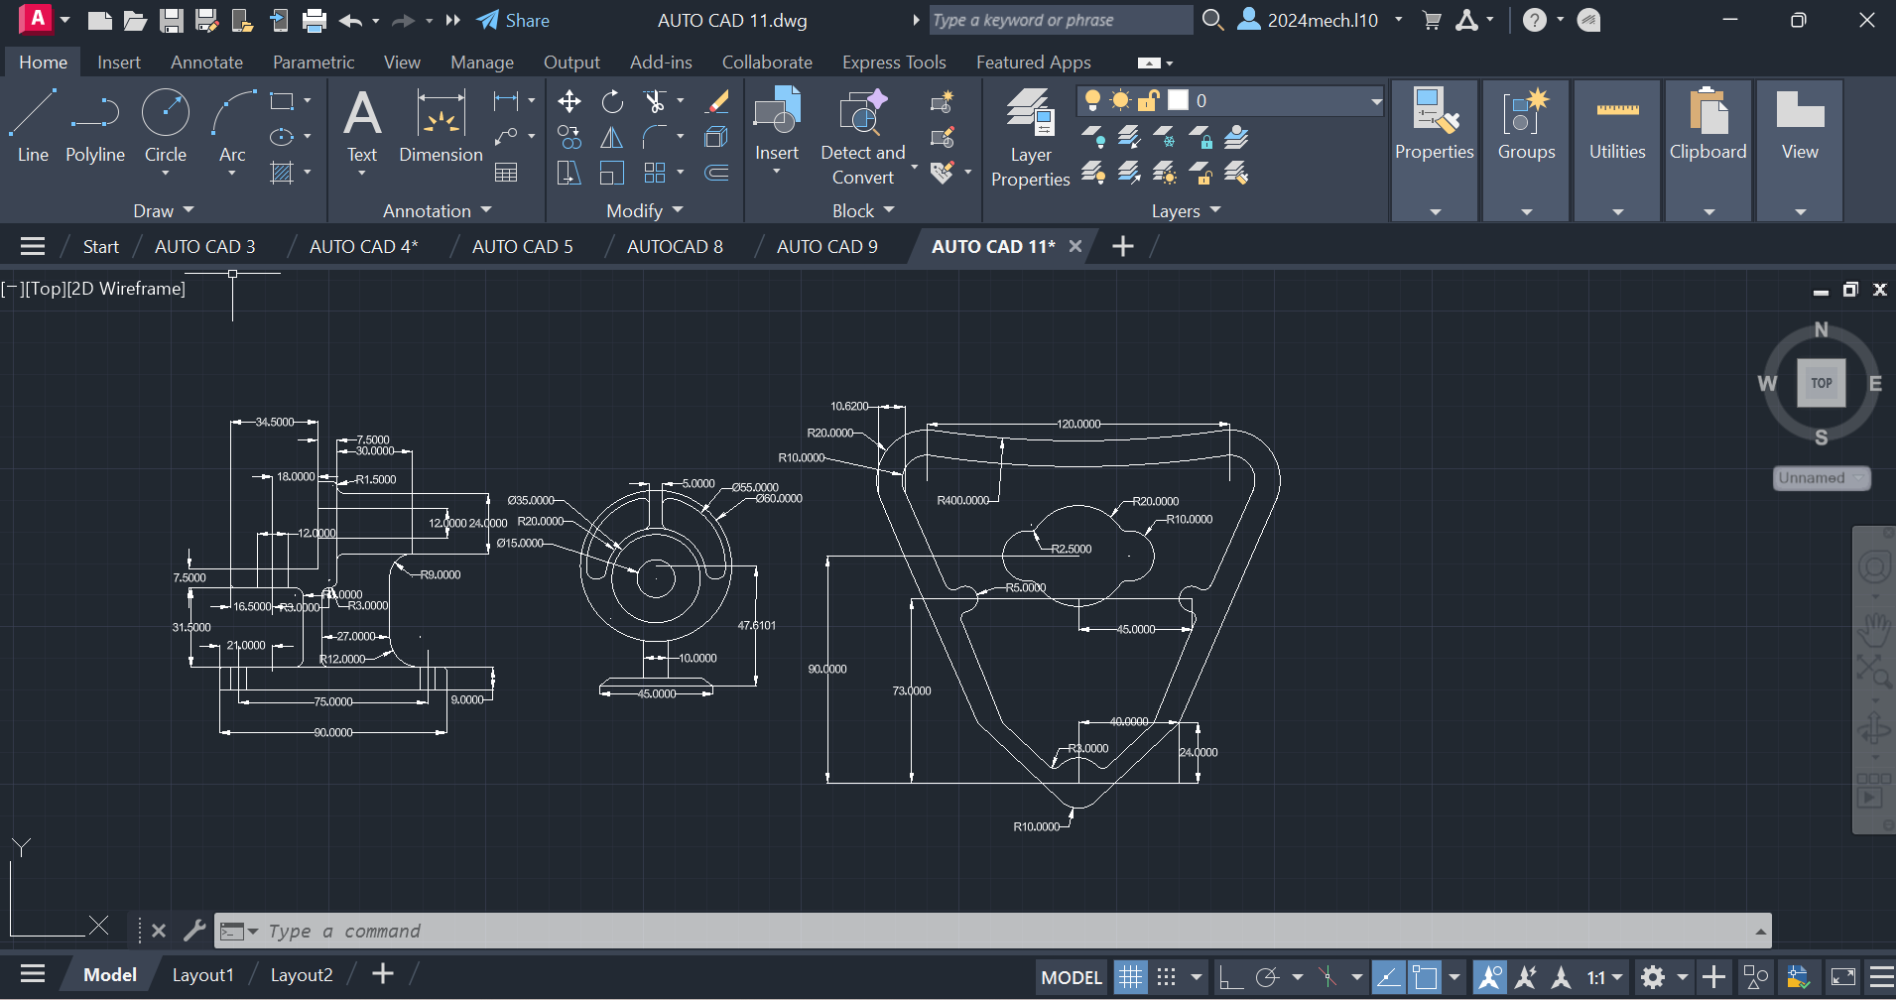

Procedure :
- First of all open autocad software in the laptop or in desktop .
- After opening, click on new the above page will appear in screen.
- If you don’t need grapical page click on ‘F7’ the grapical page will disappear in screen.
- After that press on letter ‘L’ for line command or you can directly click on line command which will be available in command box.
- Using line command draw the diagram with required dimensions.
- use the circle,trim and arc commands, where it is needed.
- change the dimensions and units by clicking letters ‘Dim’ for ‘Dimensions’ and ‘U’ for ‘Units’ after clicking change the units.
- After drawing the diagram save it in laptop or in desktop.
Assignment 8 :
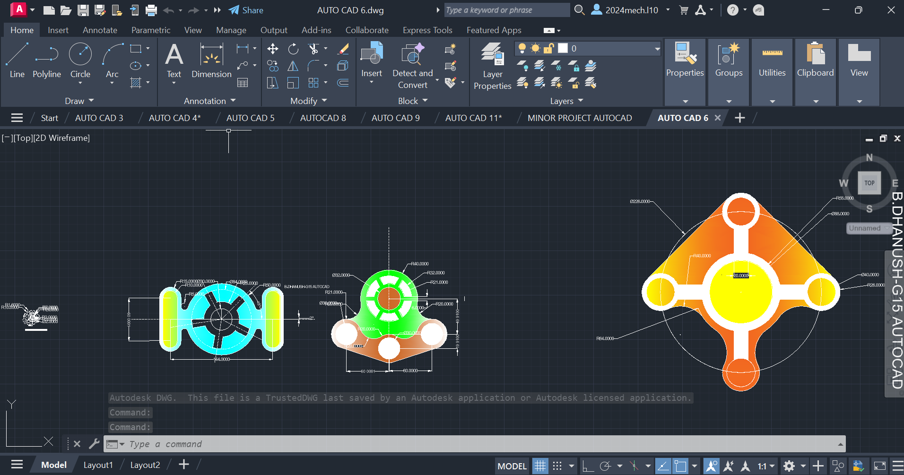

Procedure :

- First of all open autocad software in the laptop or in desktop .
- After opening, click on new the above page will appear in screen.
- If you don’t need grapical page click on ‘F7’ the grapical page will disappear in screen.
- After that press on letter ‘L’ for line command or you can directly click on line command which will be available in command box.
- Using line command draw the diagram with required dimensions.
- use the circle,trim and arc commands, where it is needed.
- change the dimensions and units by clicking letters ‘Dim’ for ‘Dimensions’ and ‘U’ for ‘Units’ after clicking change the units.
- After drawing the diagram save it in laptop or in desktop.

Assignment 9 :
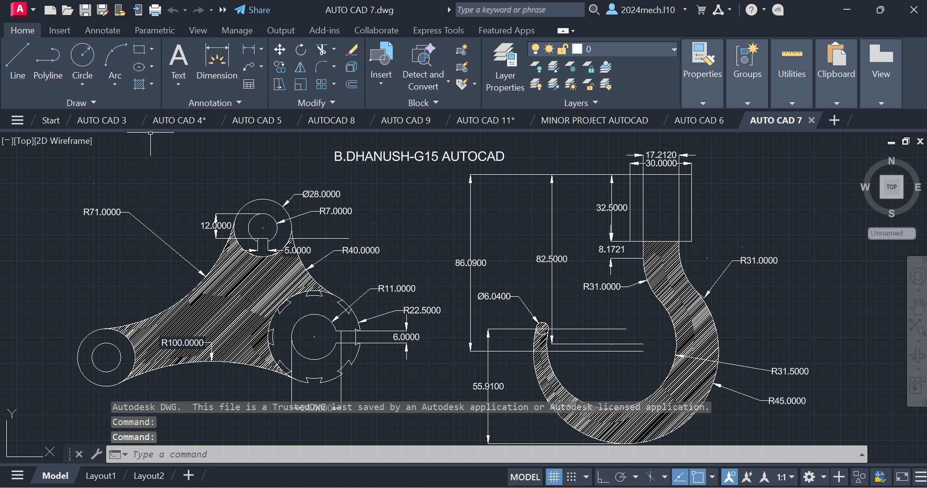
Procedure :

- First of all open autocad software in the laptop or in desktop .
- After opening, click on new the above page will appear in screen.
- If you don’t need grapical page click on ‘F7’ the grapical page will disappear in screen.
- After that press on letter ‘L’ for line command or you can directly click on line command which will be available in command box.
- Using line command draw the diagram with required dimensions.
- use the circle,trim and arc commands, where it is needed.
- change the dimensions and units by clicking letters ‘Dim’ for ‘Dimensions’ and ‘U’ for ‘Units’ after clicking change the units.
- After drawing the diagram save it in laptop or in desktop.

Assignment 10 :
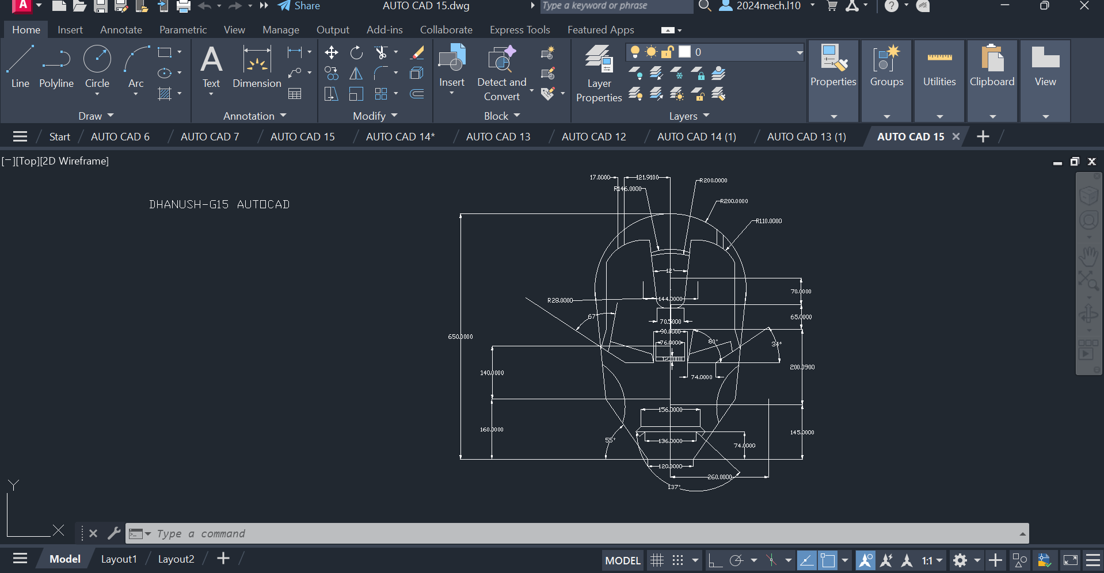

Procedure :

- First of all open autocad software in the laptop or in desktop .
- After opening, click on new the above page will appear in screen.
- If you don’t need grapical page click on ‘F7’ the grapical page will disappear in screen.
- After that press on letter ‘L’ for line command or you can directly click on line command which will be available in command box.
- Using line command draw the diagram with required dimensions.
- use the circle,trim and arc commands, where it is needed.
- change the dimensions and units by clicking letters ‘Dim’ for ‘Dimensions’ and ‘U’ for ‘Units’ after clicking change the units.
- After drawing the diagram save it in laptop or in desktop.

Assignment 11 :
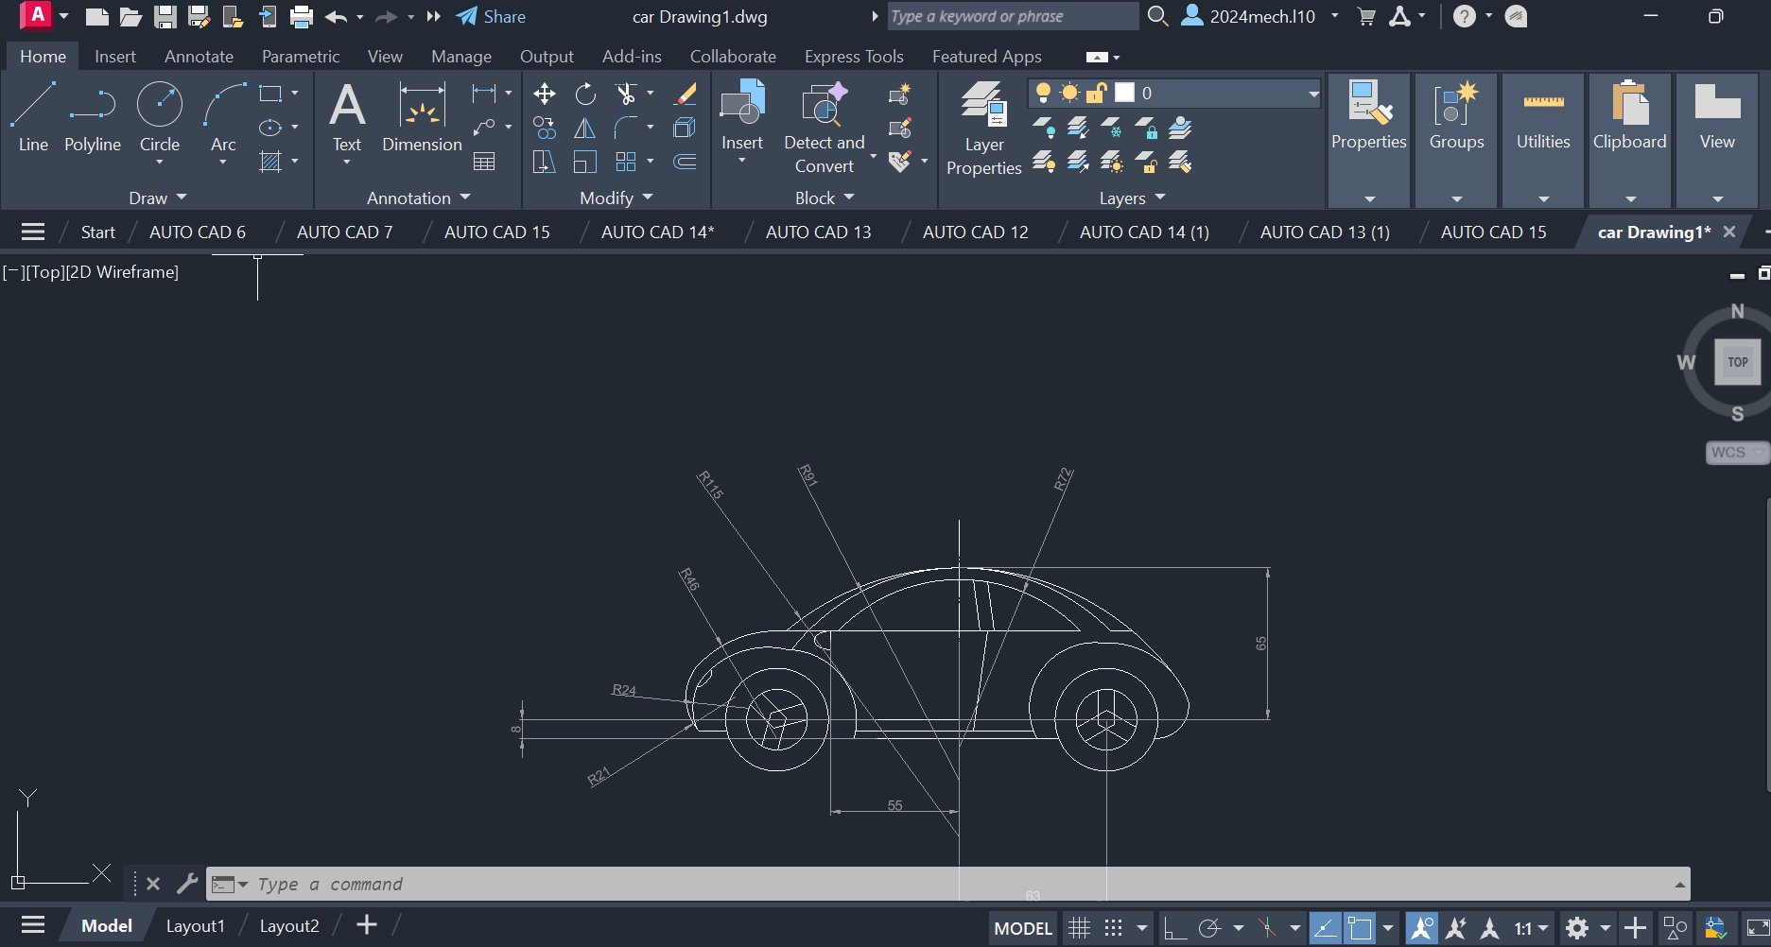

Procedure :

- First of all open autocad software in the laptop or in desktop .
- After opening, click on new the above page will appear in screen.
- If you don’t need grapical page click on ‘F7’ the grapical page will disappear in screen.
- After that press on letter ‘L’ for line command or you can directly click on line command which will be available in command box.
- Using line command draw the diagram with required dimensions.
- use the circle,trim and arc commands, where it is needed.
- change the dimensions and units by clicking letters ‘Dim’ for ‘Dimensions’ and ‘U’ for ‘Units’ after clicking change the units.
- After drawing the diagram save it in laptop or in desktop.

Assignment 12 :
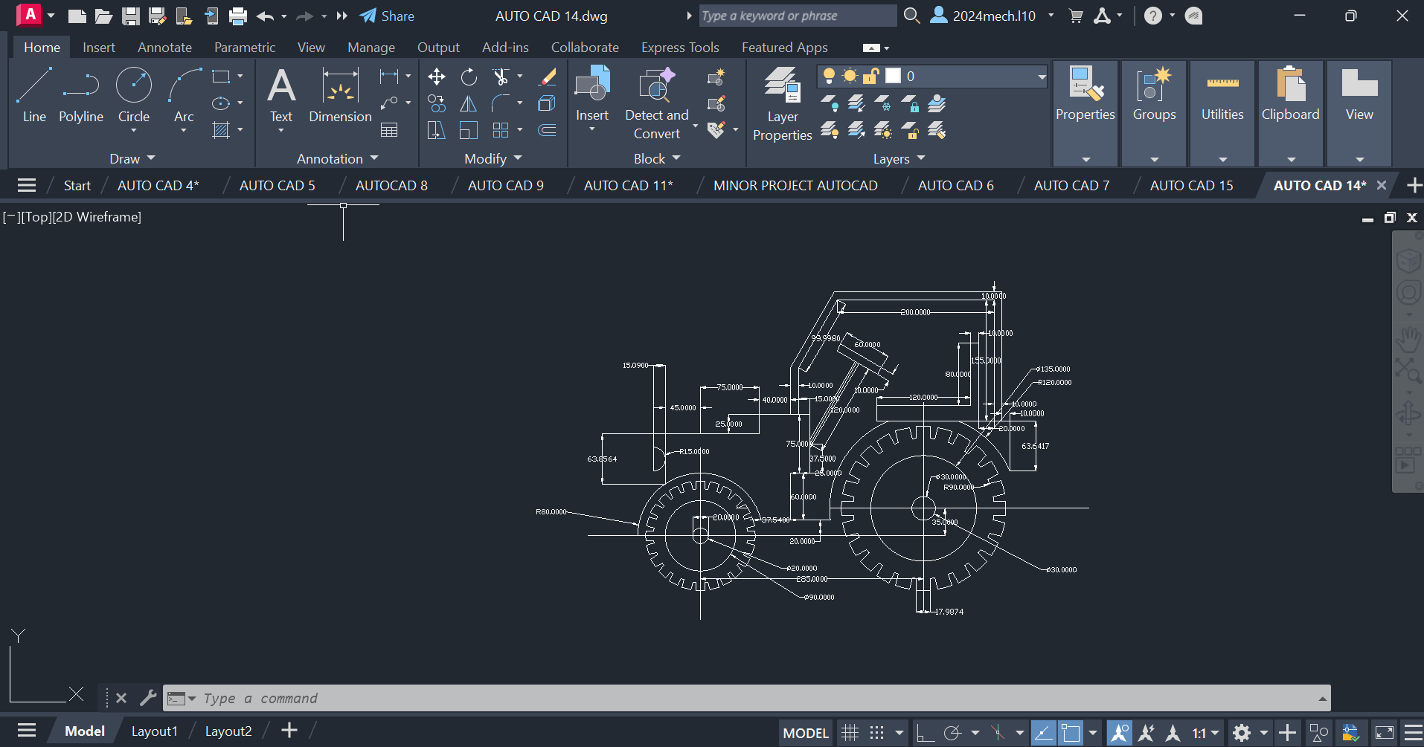

Procedure :

- First of all open autocad software in the laptop or in desktop .
- After opening, click on new the above page will appear in screen.
- If you don’t need grapical page click on ‘F7’ the grapical page will disappear in screen.
- After that press on letter ‘L’ for line command or you can directly click on line command which will be available in command box.
- Using line command draw the diagram with required dimensions.
- use the circle,trim and arc commands, where it is needed.
- change the dimensions and units by clicking letters ‘Dim’ for ‘Dimensions’ and ‘U’ for ‘Units’ after clicking change the units.
- After drawing the diagram save it in laptop or in desktop.

Projects
Project 1:
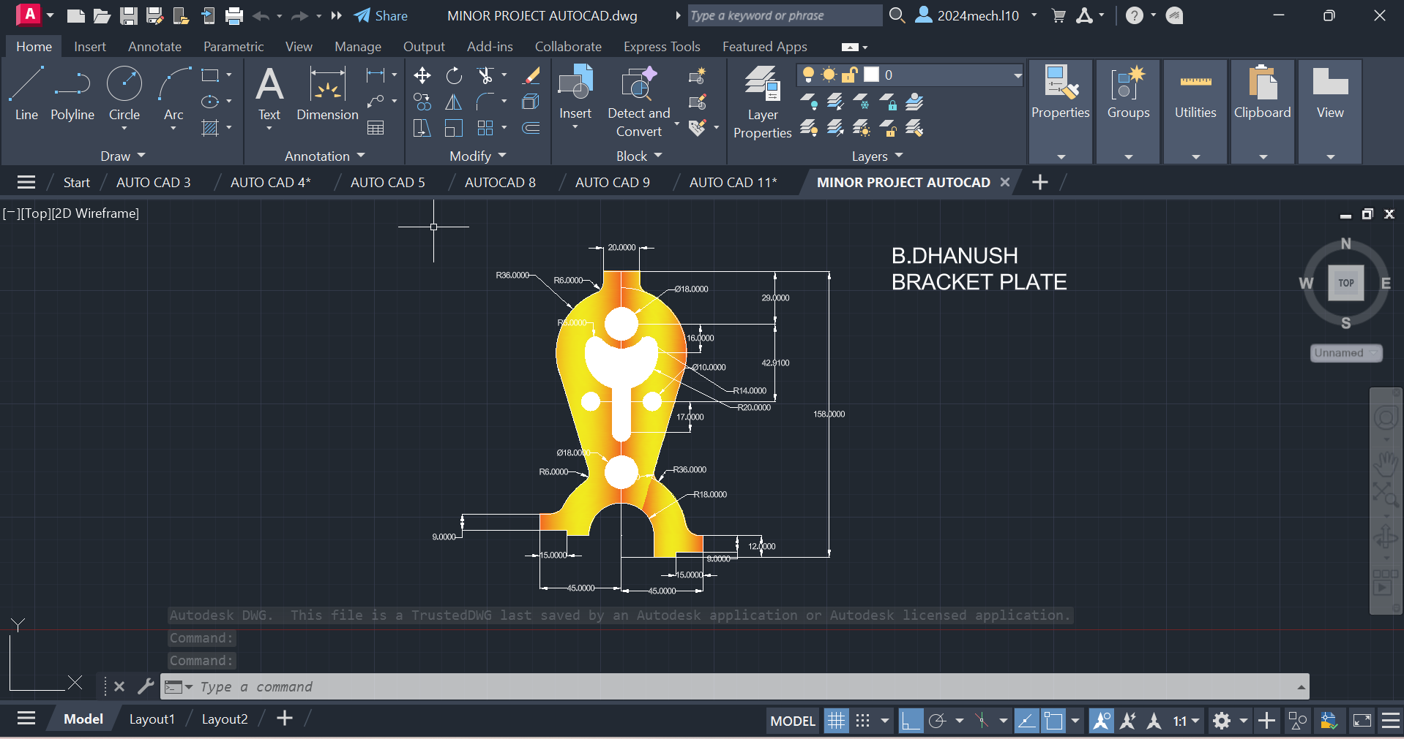
Procedure :

- First of all open autocad software in the laptop or in desktop .
- After opening, click on new the above page will appear in screen.
- If you don’t need grapical page click on ‘F7’ the grapical page will disappear in screen.
- After that press on letter ‘L’ for line command or you can directly click on line command which will be available in command box.
- Using line command draw the diagram with required dimensions.
- use the circle,trim and arc commands, where it is needed.
- change the dimensions and units by clicking letters ‘Dim’ for ‘Dimensions’ and ‘U’ for ‘Units’ after clicking change the units.
- After drawing the diagram save it in laptop or in desktop.
Project 2:
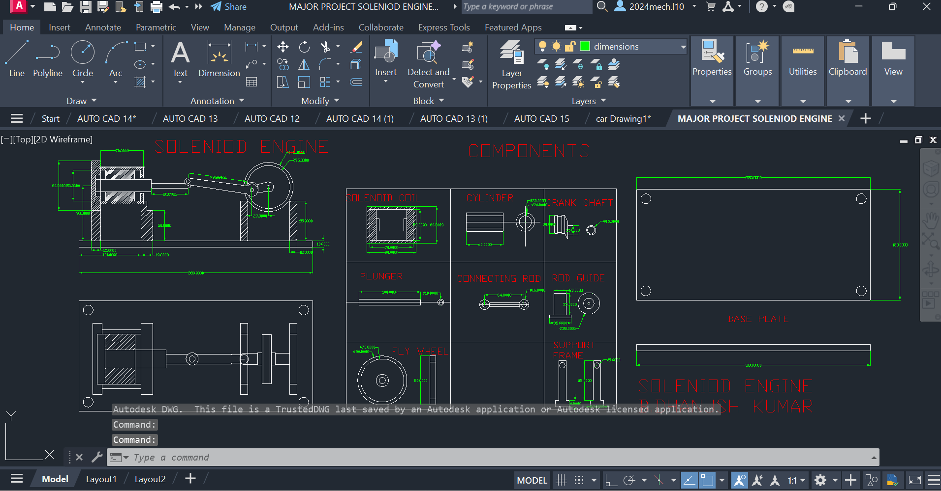Procedure :
- First of all open autocad software in the laptop or in desktop .
- After opening, click on new the above page will appear in screen.
- If you don’t need grapical page click on ‘F7’ the grapical page will disappear in screen.
- After that press on letter ‘L’ for line command or you can directly click on line command which will be available in command box.
- Using line command draw the diagram with required dimensions.
- use the circle,trim and arc commands, where it is needed.
- change the dimensions and units by clicking letters ‘Dim’ for ‘Dimensions’ and ‘U’ for ‘Units’ after clicking change the units.
- After drawing the diagram save it in laptop or in desktop.
SOLIDWORKS
SolidWorks is a solid modeling computer-aided design (CAD) and computer-aided engineering (CAE) application published by Dassault Systems.
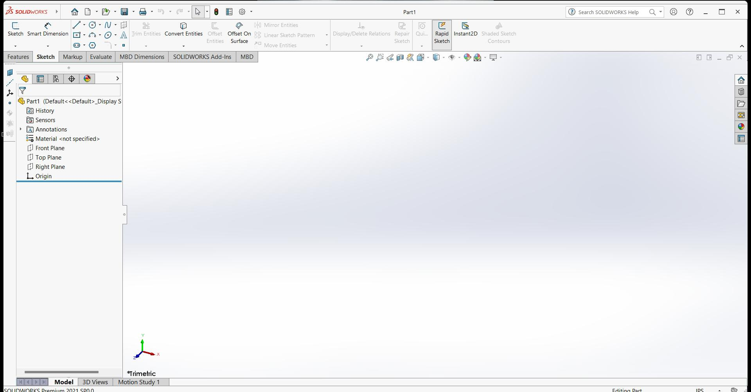
SOLIDWORKS is used to develop mechatronics systems from beginning to end. At the initial stage, the software is used for planning, visual ideation, modeling, feasibility assessment, prototyping, and project management. The software is then used for design and building of mechanical, electrical, and software elements.

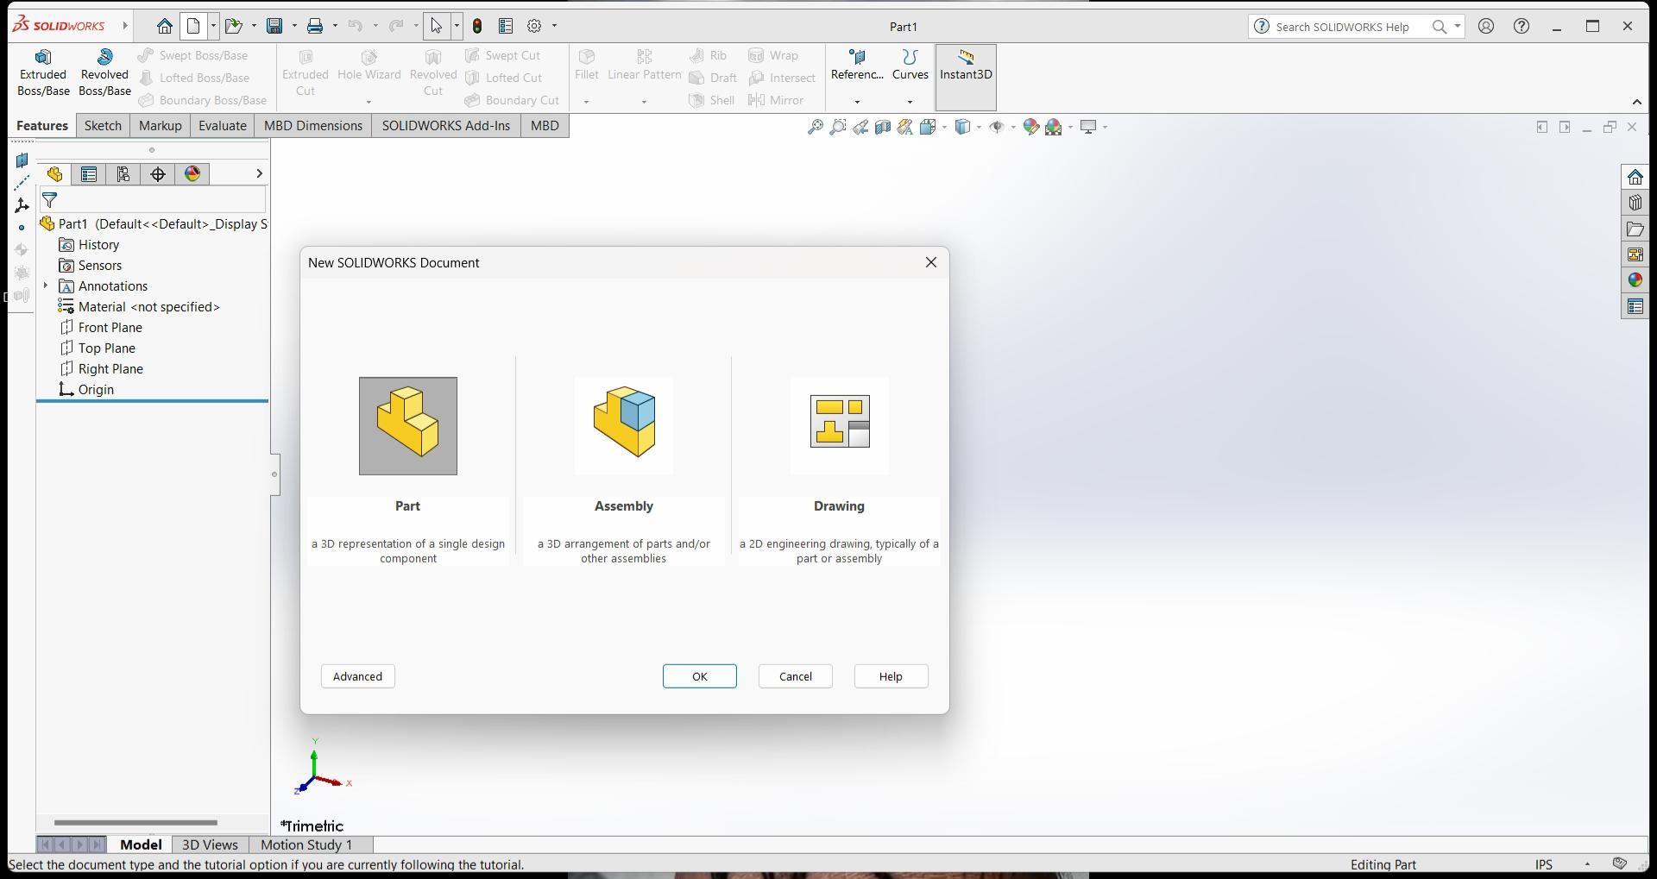
Solidworks mainly consists of
- Part Modeling,3DModeling
- Assembly, sheet metal, weld meats
- Drawing

_{Part Modeling 2D :}

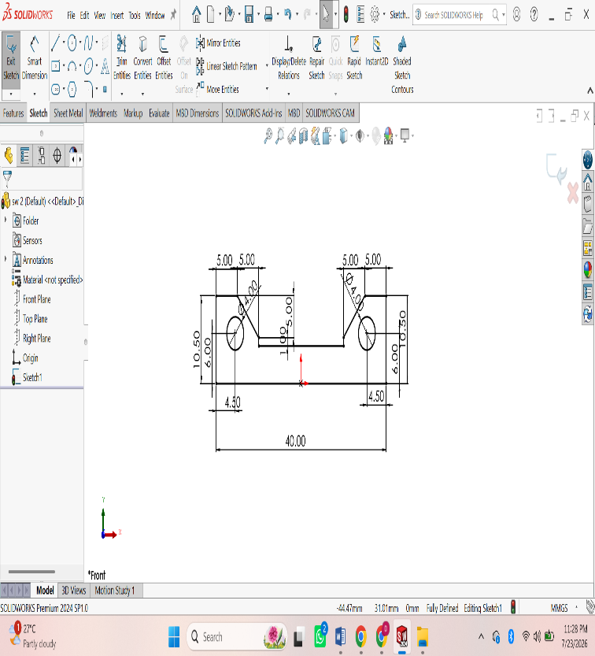
ASSIGNMENT 1:
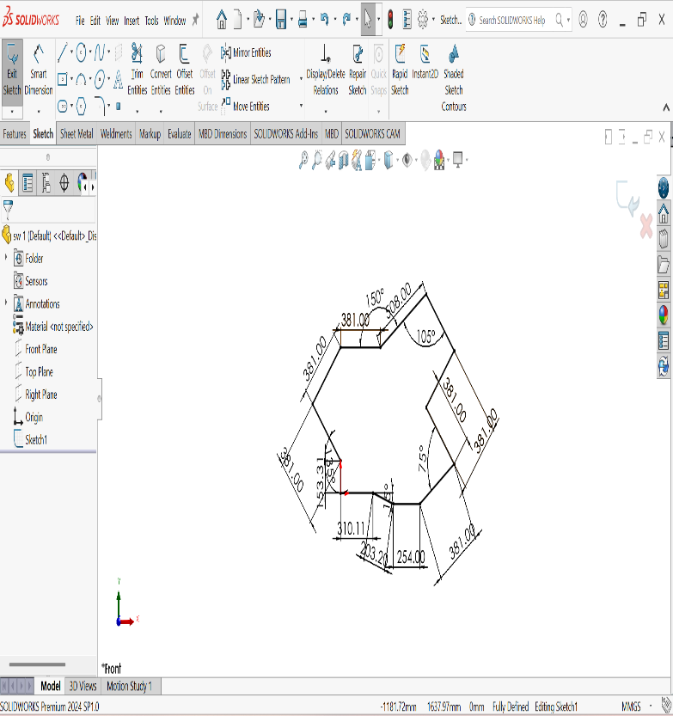
Procedure :
Open SOLIDWORKS.
• Click File → New → Part and select OK.
• Select a sketch plane (Front Plane, Top Plane, or Right Plane) from the FeatureManager.
• Click Sketch on the CommandManager to enter sketch mode.
• Use sketch tools to draw the required geometry:
- Line
- Rectangle
- Circle
- Center Rectangle
- Arc
- Polygon
- Spline (if required)
• Apply Smart Dimensions to define the size of the sketch.
• Add Sketch Relations (Horizontal, Vertical, Parallel, Perpendicular, Coincident, Tangent, Equal, etc.) to fully define the sketch.
• Ensure the sketch changes from blue (under-defined) to black (fully defined).
• Use Trim Entities or Extend Entities to modify the sketch if necessary.
• Click Exit Sketch to complete the 2D sketch.
• Save the part by selecting File → Save As and entering a file name.

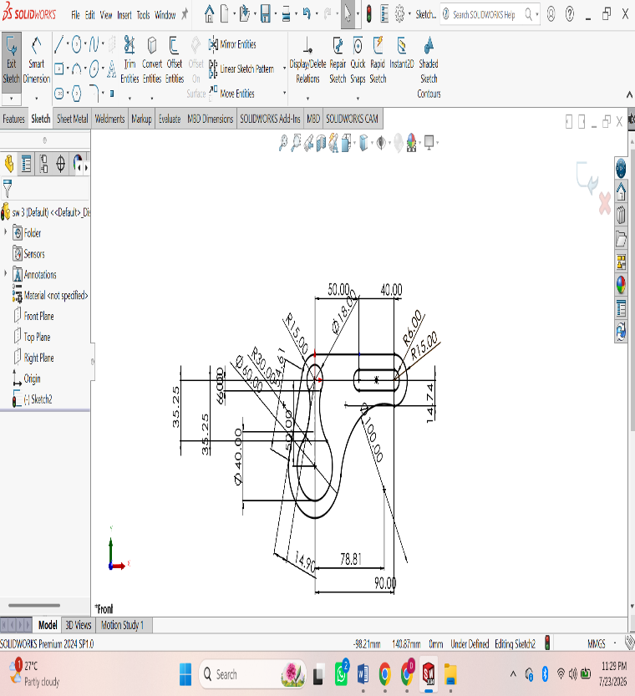
ASSIGNMENT 2:
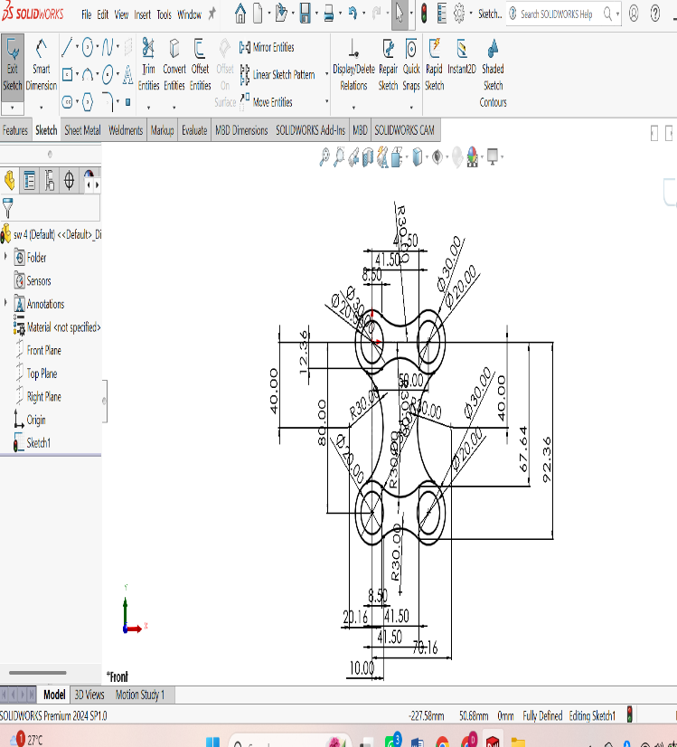
Procedure :
Open SOLIDWORKS.
• Click File → New → Part and select OK.
• Select a sketch plane (Front Plane, Top Plane, or Right Plane) from the FeatureManager.
• Click Sketch on the CommandManager to enter sketch mode.
• Use sketch tools to draw the required geometry:
- Line
- Rectangle
- Circle
- Center Rectangle
- Arc
- Polygon
- Spline (if required)
• Apply Smart Dimensions to define the size of the sketch.
• Add Sketch Relations (Horizontal, Vertical, Parallel, Perpendicular, Coincident, Tangent, Equal, etc.) to fully define the sketch.
• Ensure the sketch changes from blue (under-defined) to black (fully defined).
• Use Trim Entities or Extend Entities to modify the sketch if necessary.
• Click Exit Sketch to complete the 2D sketch.
• Save the part by selecting File → Save As and entering a file name.

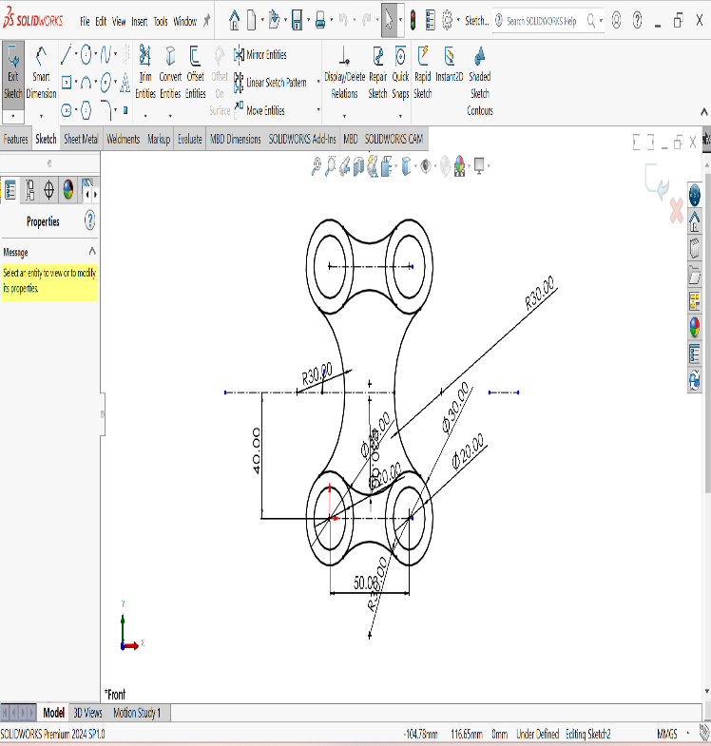
ASSIGNMENT 3:
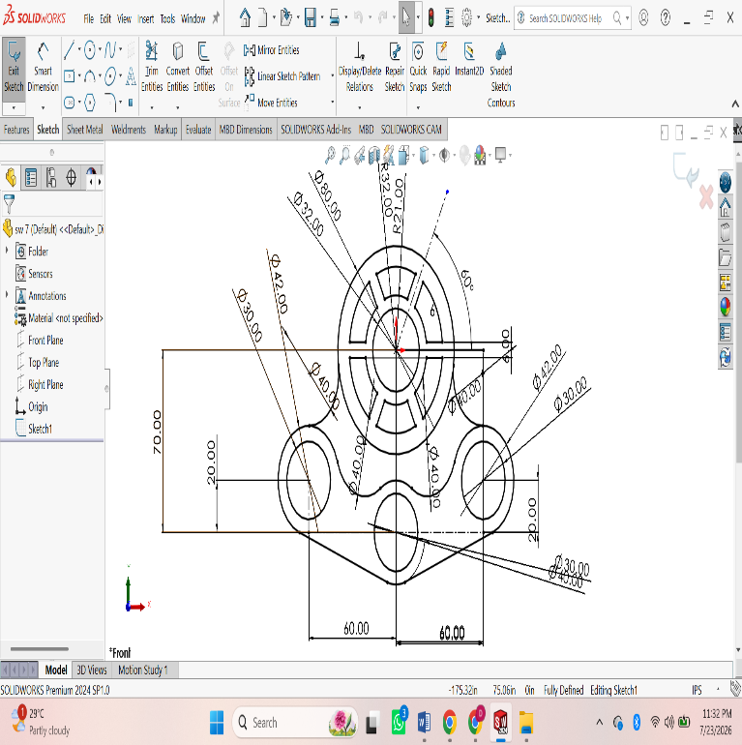
Procedure :
Open SOLIDWORKS.
• Click File → New → Part and select OK.
• Select a sketch plane (Front Plane, Top Plane, or Right Plane) from the FeatureManager.
• Click Sketch on the CommandManager to enter sketch mode.
• Use sketch tools to draw the required geometry:
- Line
- Rectangle
- Circle
- Center Rectangle
- Arc
- Polygon
- Spline (if required)
• Apply Smart Dimensions to define the size of the sketch.
• Add Sketch Relations (Horizontal, Vertical, Parallel, Perpendicular, Coincident, Tangent, Equal, etc.) to fully define the sketch.
• Ensure the sketch changes from blue (under-defined) to black (fully defined).
• Use Trim Entities or Extend Entities to modify the sketch if necessary.
• Click Exit Sketch to complete the 2D sketch.
• Save the part by selecting File → Save As and entering a file name.
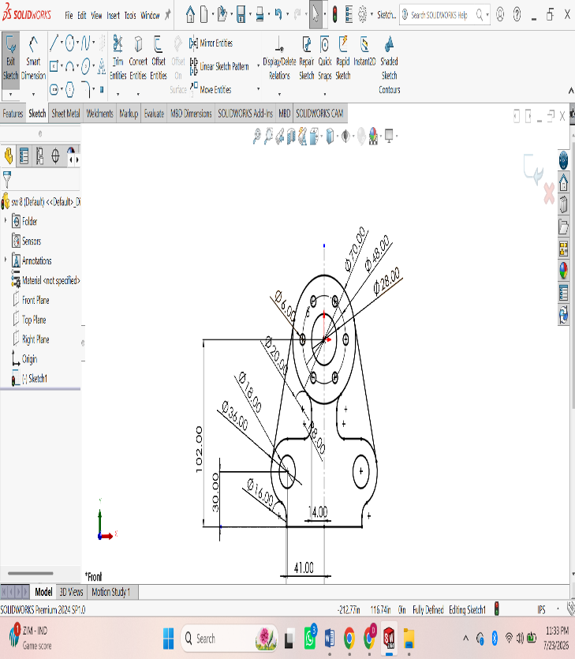
ASSIGNMENT 4:
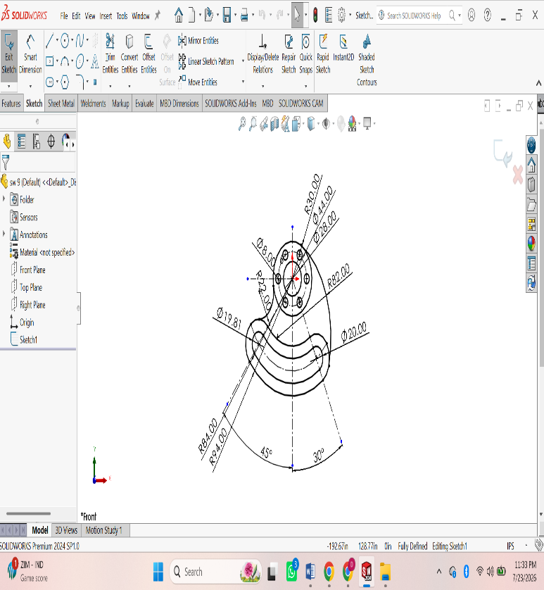
Procedure :
Open SOLIDWORKS.
• Click File → New → Part and select OK.
• Select a sketch plane (Front Plane, Top Plane, or Right Plane) from the FeatureManager.
• Click Sketch on the CommandManager to enter sketch mode.
• Use sketch tools to draw the required geometry:
- Line
- Rectangle
- Circle
- Center Rectangle
- Arc
- Polygon
- Spline (if required)
• Apply Smart Dimensions to define the size of the sketch.
• Add Sketch Relations (Horizontal, Vertical, Parallel, Perpendicular, Coincident, Tangent, Equal, etc.) to fully define the sketch.
• Ensure the sketch changes from blue (under-defined) to black (fully defined).
• Use Trim Entities or Extend Entities to modify the sketch if necessary.
• Click Exit Sketch to complete the 2D sketch.
• Save the part by selecting File → Save As and entering a file name.

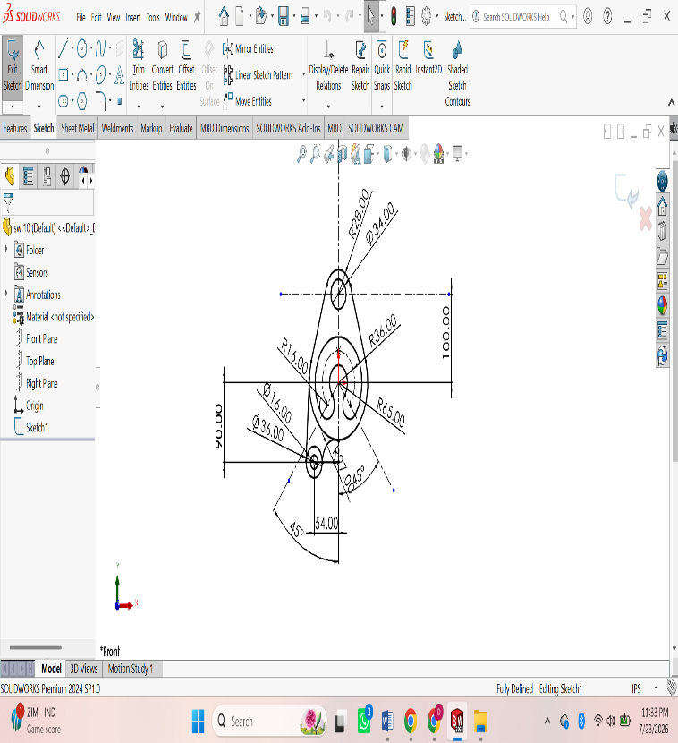
ASSIGNMENT 5:
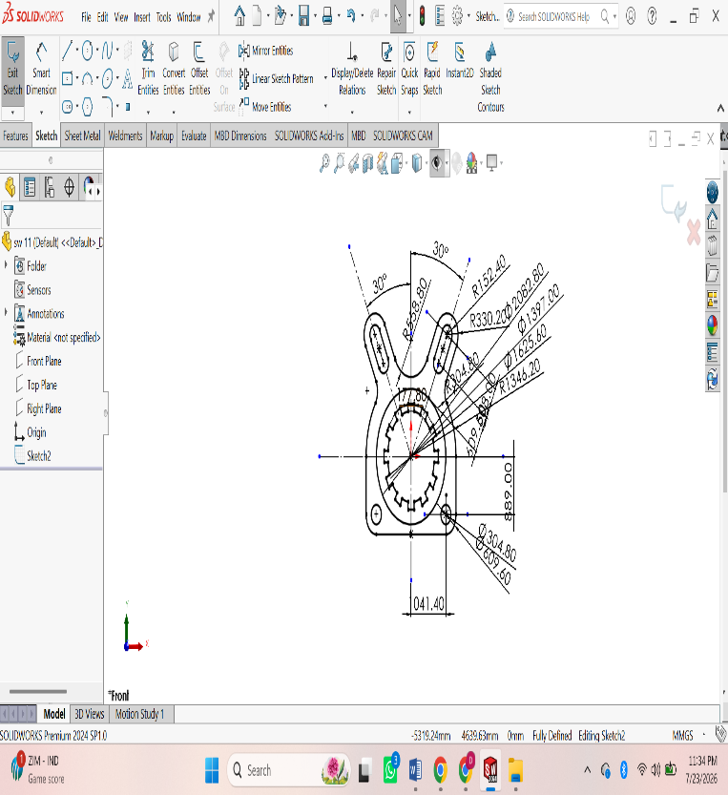
Procedure :
Open SOLIDWORKS.
• Click File → New → Part and select OK.
• Select a sketch plane (Front Plane, Top Plane, or Right Plane) from the FeatureManager.
• Click Sketch on the CommandManager to enter sketch mode.
• Use sketch tools to draw the required geometry:
- Line
- Rectangle
- Circle
- Center Rectangle
- Arc
- Polygon
- Spline (if required)
• Apply Smart Dimensions to define the size of the sketch.
• Add Sketch Relations (Horizontal, Vertical, Parallel, Perpendicular, Coincident, Tangent, Equal, etc.) to fully define the sketch.
• Ensure the sketch changes from blue (under-defined) to black (fully defined).
• Use Trim Entities or Extend Entities to modify the sketch if necessary.
• Click Exit Sketch to complete the 2D sketch.
• Save the part by selecting File → Save As and entering a file name.
ASSIGNMENT 6:
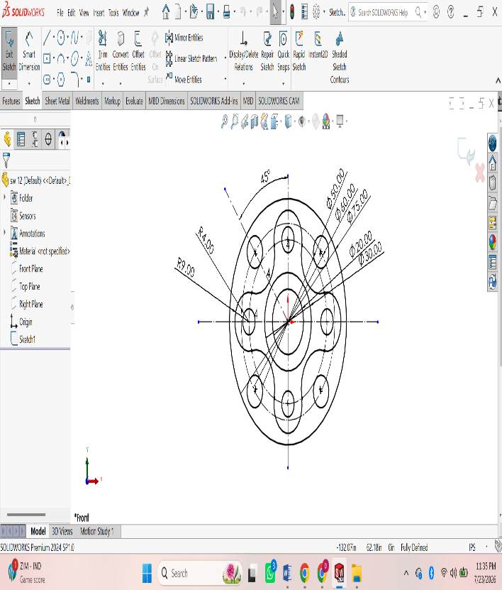
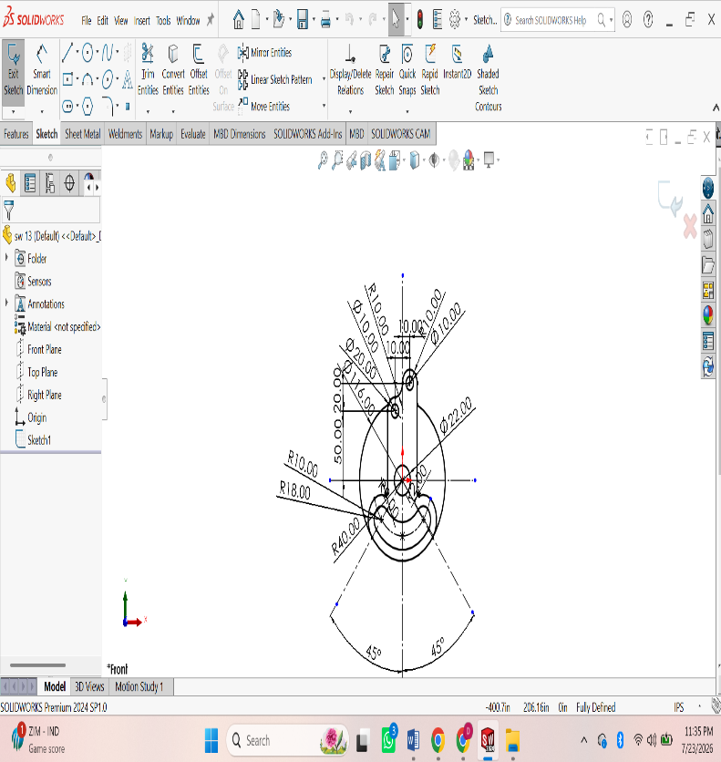
Procedure :
Open SOLIDWORKS.
• Click File → New → Part and select OK.
• Select a sketch plane (Front Plane, Top Plane, or Right Plane) from the FeatureManager.
• Click Sketch on the CommandManager to enter sketch mode.
• Use sketch tools to draw the required geometry:
- Line
- Rectangle
- Circle
- Center Rectangle
- Arc
- Polygon
- Spline (if required)
• Apply Smart Dimensions to define the size of the sketch.
• Add Sketch Relations (Horizontal, Vertical, Parallel, Perpendicular, Coincident, Tangent, Equal, etc.) to fully define the sketch.
• Ensure the sketch changes from blue (under-defined) to black (fully defined).
• Use Trim Entities or Extend Entities to modify the sketch if necessary.
• Click Exit Sketch to complete the 2D sketch.
• Save the part by selecting File → Save As and entering a file name.
ASSIGNMENT 7:
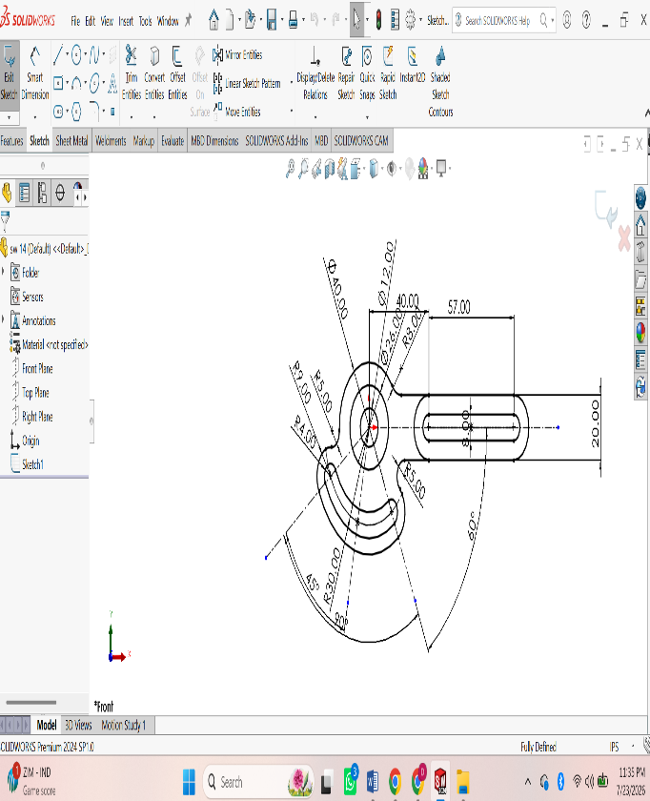
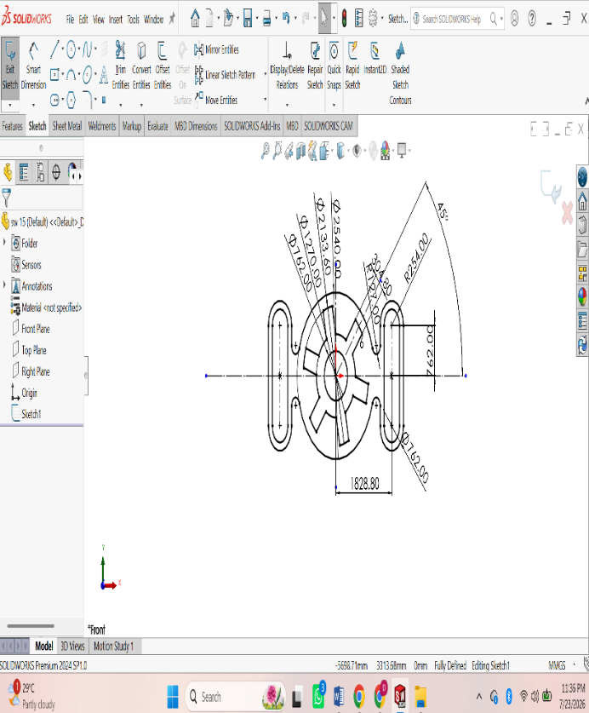
Procedure :
Open SOLIDWORKS.
• Click File → New → Part and select OK.
• Select a sketch plane (Front Plane, Top Plane, or Right Plane) from the FeatureManager.
• Click Sketch on the CommandManager to enter sketch mode.
• Use sketch tools to draw the required geometry:
- Line
- Rectangle
- Circle
- Center Rectangle
- Arc
- Polygon
- Spline (if required)
• Apply Smart Dimensions to define the size of the sketch.
• Add Sketch Relations (Horizontal, Vertical, Parallel, Perpendicular, Coincident, Tangent, Equal, etc.) to fully define the sketch.
• Ensure the sketch changes from blue (under-defined) to black (fully defined).
• Use Trim Entities or Extend Entities to modify the sketch if necessary.
• Click Exit Sketch to complete the 2D sketch.
• Save the part by selecting File → Save As and entering a file name.
ASSIGNMENT 8:
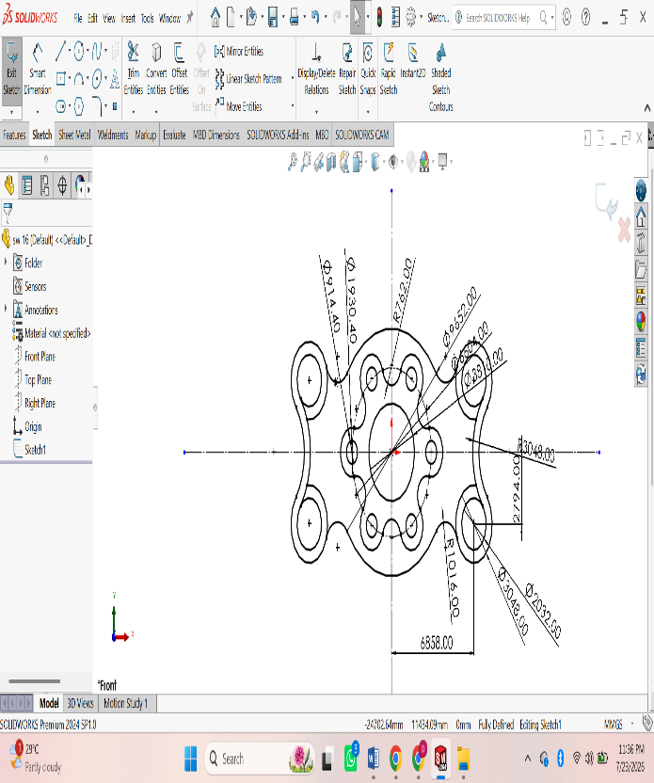
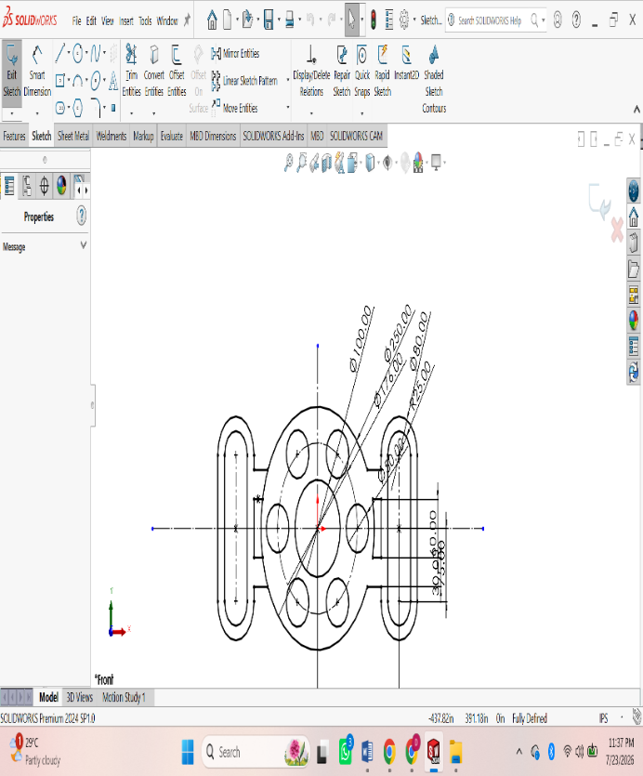
Procedure :
Open SOLIDWORKS.
• Click File → New → Part and select OK.
• Select a sketch plane (Front Plane, Top Plane, or Right Plane) from the FeatureManager.
• Click Sketch on the CommandManager to enter sketch mode.
• Use sketch tools to draw the required geometry:
- Line
- Rectangle
- Circle
- Center Rectangle
- Arc
- Polygon
- Spline (if required)
• Apply Smart Dimensions to define the size of the sketch.
• Add Sketch Relations (Horizontal, Vertical, Parallel, Perpendicular, Coincident, Tangent, Equal, etc.) to fully define the sketch.
• Ensure the sketch changes from blue (under-defined) to black (fully defined).
• Use Trim Entities or Extend Entities to modify the sketch if necessary.
• Click Exit Sketch to complete the 2D sketch.
• Save the part by selecting File → Save As and entering a file name.
ASSIGNMENT 9:
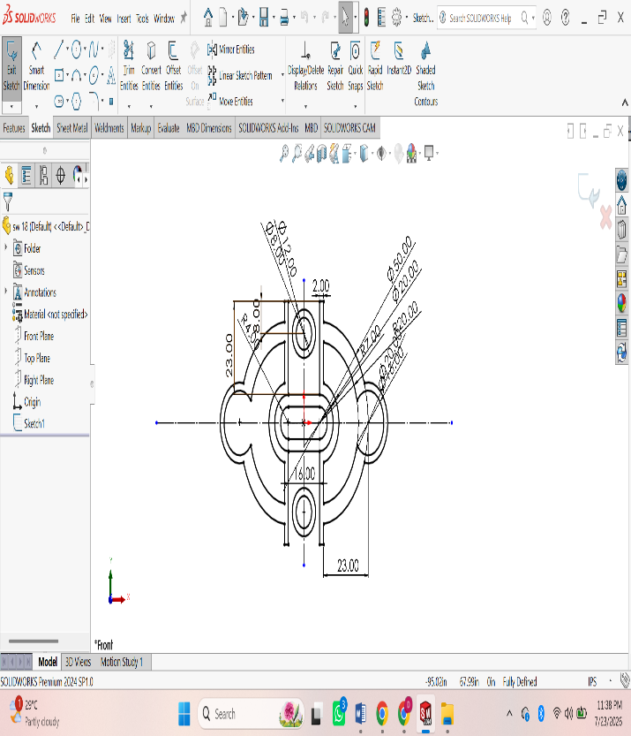
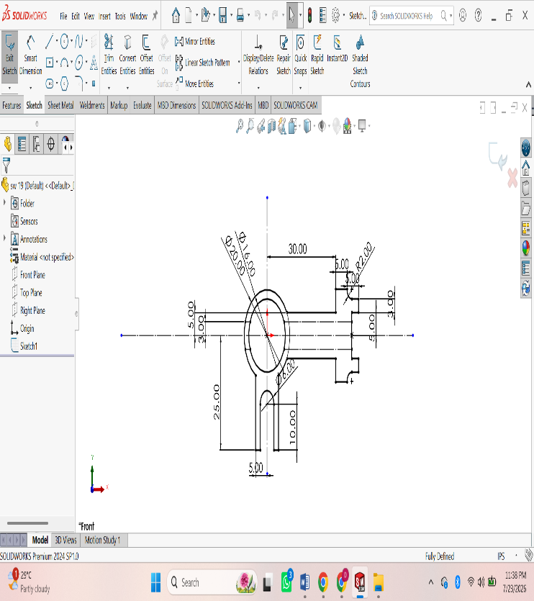
Procedure :
Open SOLIDWORKS.
• Click File → New → Part and select OK.
• Select a sketch plane (Front Plane, Top Plane, or Right Plane) from the FeatureManager.
• Click Sketch on the CommandManager to enter sketch mode.
• Use sketch tools to draw the required geometry:
- Line
- Rectangle
- Circle
- Center Rectangle
- Arc
- Polygon
- Spline (if required)
• Apply Smart Dimensions to define the size of the sketch.
• Add Sketch Relations (Horizontal, Vertical, Parallel, Perpendicular, Coincident, Tangent, Equal, etc.) to fully define the sketch.
• Ensure the sketch changes from blue (under-defined) to black (fully defined).
• Use Trim Entities or Extend Entities to modify the sketch if necessary.
• Click Exit Sketch to complete the 2D sketch.
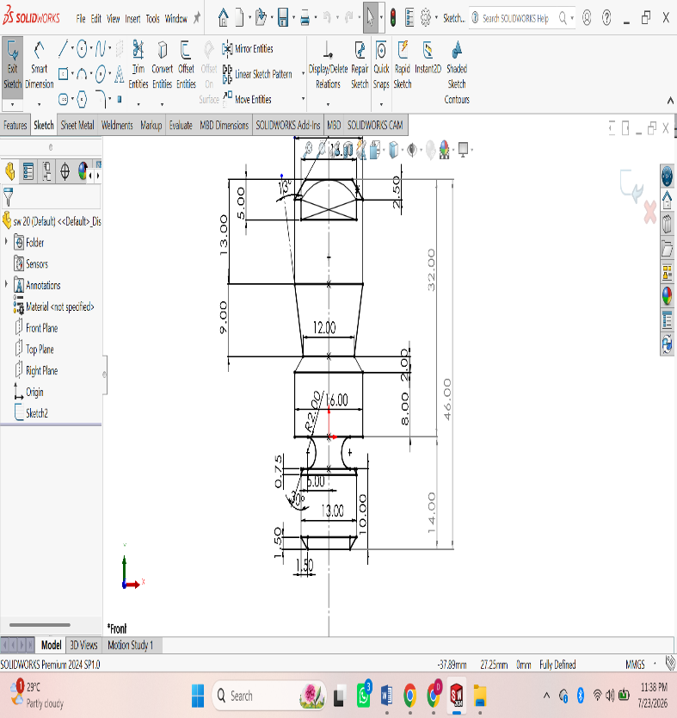
ASSIGNMENT 10:
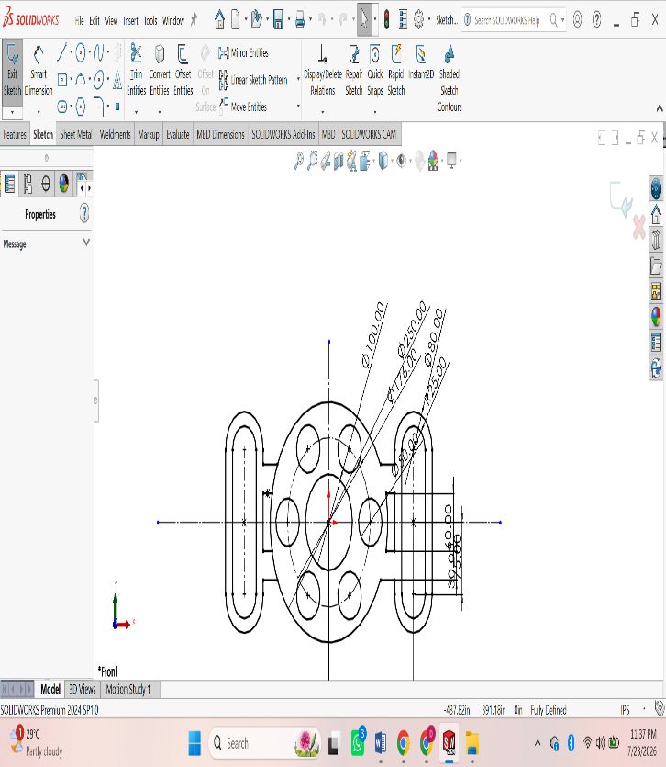
Procedure :
Open SOLIDWORKS.
• Click File → New → Part and select OK.
• Select a sketch plane (Front Plane, Top Plane, or Right Plane) from the FeatureManager.
• Click Sketch on the CommandManager to enter sketch mode.
• Use sketch tools to draw the required geometry:
- Line
- Rectangle
- Circle
- Center Rectangle
- Arc
- Polygon
- Spline (if required)
• Apply Smart Dimensions to define the size of the sketch.
• Add Sketch Relations (Horizontal, Vertical, Parallel, Perpendicular, Coincident, Tangent, Equal, etc.) to fully define the sketch.
• Ensure the sketch changes from blue (under-defined) to black (fully defined).
• Use Trim Entities or Extend Entities to modify the sketch if necessary.
• Click Exit Sketch to complete the 2D sketch.
• Save the part by selecting File → Save As and entering a file name.

3D MODELING
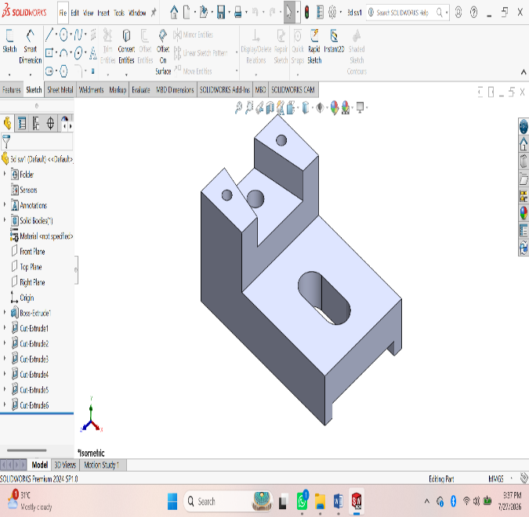
ASSIGNMENT 1:
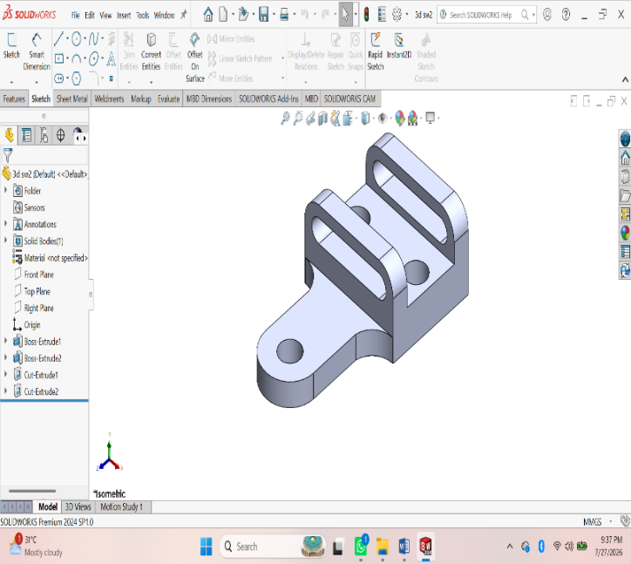Procedure :
- First of all open solidworks software in the laptop or in desktop.
- After opening, click on new the above page will appear in screen.
- After that click on frount view the sketch chuck box will be appear click on it for further step.
- In that page a small rectangular box will appear at above the date and time box, there change the units from ‘MKS’ to ‘MMGS’ units.
- Using ‘Circle’ command draw the diagram with required dimensions by giving alignments to circle.
- After drawing open ‘Extrude’ command and extrude upto required dimensions.
- After that click on top of the extrude part, a sketch box will be appear click on it.
- Again Use Line command and draw the next swept part.
- After drawing, by using ‘swept’ command draw the thread upto required dimensions.
- After drawing the diagram save it in laptop or in desktop
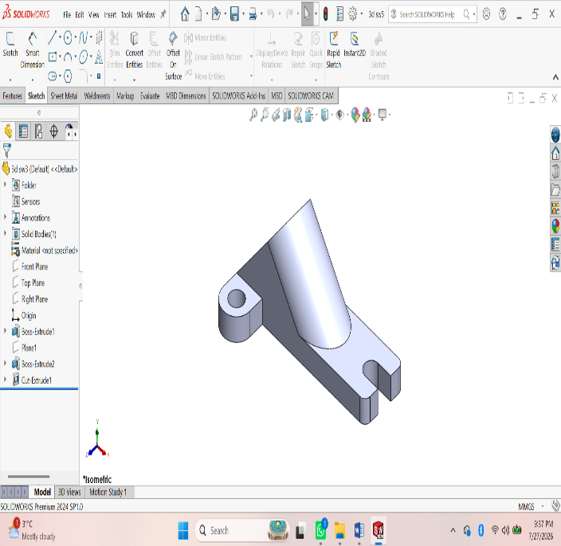
ASSIGNMENT 2:
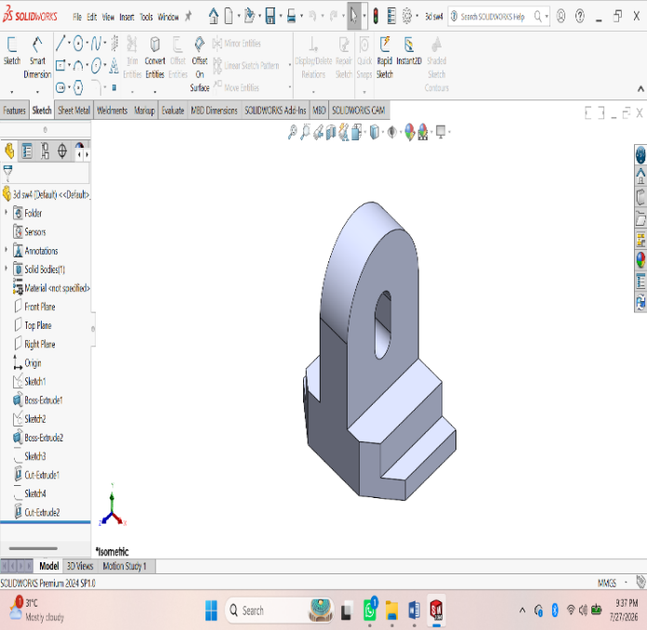Procedure :
- First of all open solidworks software in the laptop or in desktop.
- After opening, click on new the above page will appear in screen.
- After that click on frount view the sketch chuck box will be appear click on it for further step.
- In that page a small rectangular box will appear at above the date and time box, there change the units from ‘MKS’ to ‘MMGS’ units.
- Using ‘Circle’ command draw the diagram with required dimensions by giving alignments to circle.
- After drawing open ‘Extrude’ command and extrude upto required dimensions.
- After that click on top of the extrude part, a sketch box will be appear click on it.
- Again Use Line command and draw the next swept part.
- After drawing, by using ‘swept’ command draw the thread upto required dimensions.
10. After drawing the diagram save it in laptop or in desktop.
ASSIGNMENT 3:
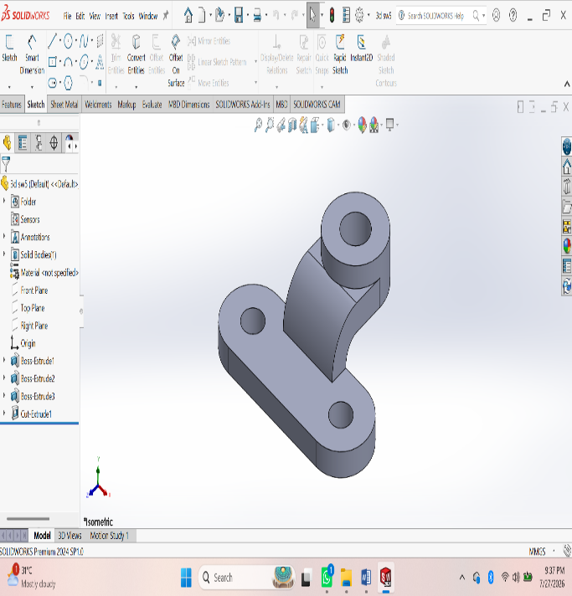
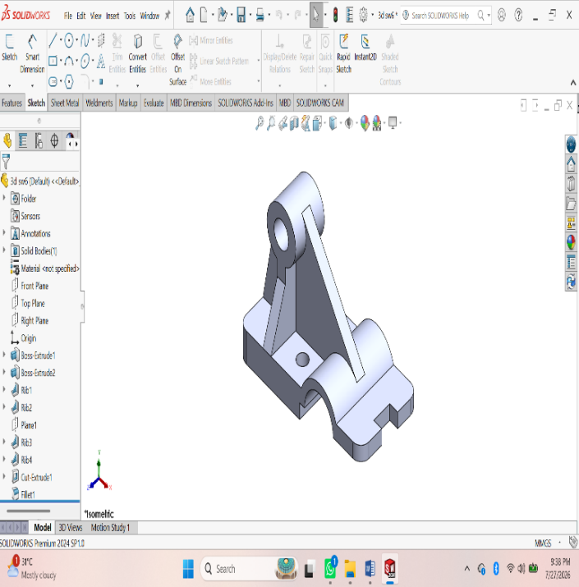Procedure :
- First of all open solidworks software in the laptop or in desktop.
- After opening, click on new the above page will appear in screen.
- After that click on frount view the sketch chuck box will be appear click on it for further step.
- In that page a small rectangular box will appear at above the date and time box, there change the units from ‘MKS’ to ‘MMGS’ units.
- Using ‘Circle’ command draw the diagram with required dimensions by giving alignments to circle.
- After drawing open ‘Extrude’ command and extrude upto required dimensions.
- After that click on top of the extrude part, a sketch box will be appear click on it.
- Again Use Line command and draw the next swept part.
- After drawing, by using ‘swept’ command draw the thread upto required dimensions.
10. After drawing the diagram save it in laptop or in desktop.
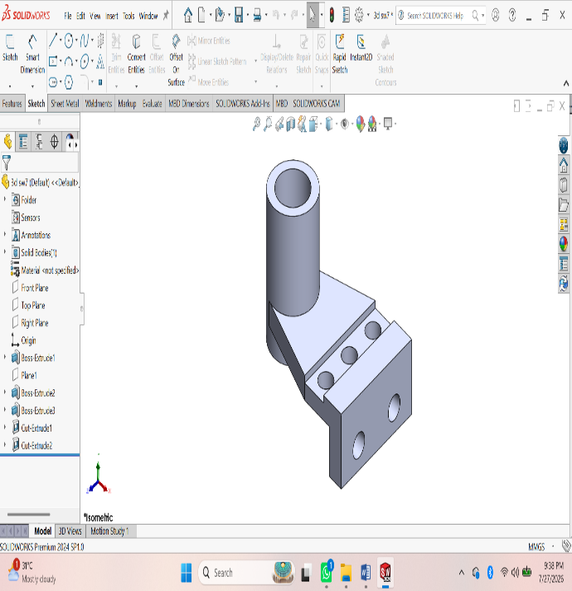
ASSIGNMENT 4:
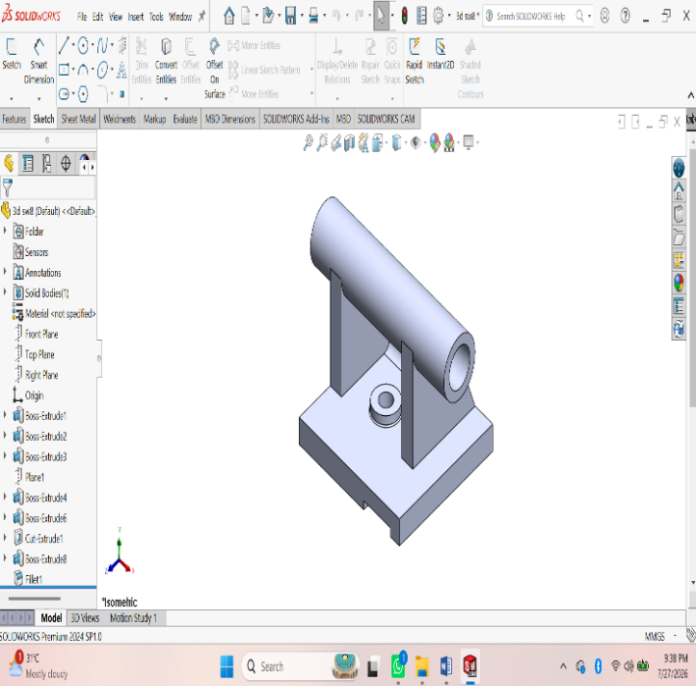Procedure :
- First of all open solidworks software in the laptop or in desktop.
- After opening, click on new the above page will appear in screen.
- After that click on frount view the sketch chuck box will be appear click on it for further step.
- In that page a small rectangular box will appear at above the date and time box, there change the units from ‘MKS’ to ‘MMGS’ units.
- Using ‘Circle’ command draw the diagram with required dimensions by giving alignments to circle.
- After drawing open ‘Extrude’ command and extrude upto required dimensions.
- After that click on top of the extrude part, a sketch box will be appear click on it.
- Again Use Line command and draw the next swept part.
- After drawing, by using ‘swept’ command draw the thread upto required dimensions.
10. After drawing the diagram save it in laptop or in desktop.
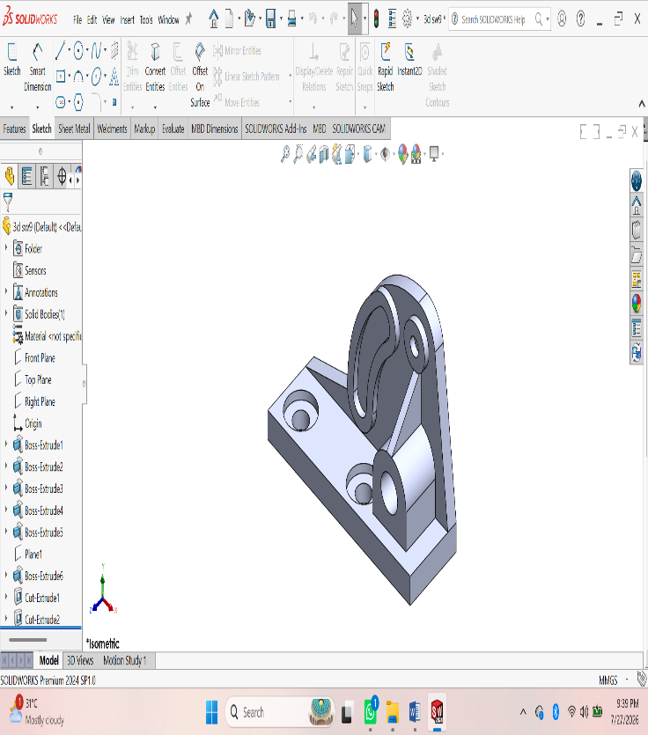
ASSIGNMENT 5:
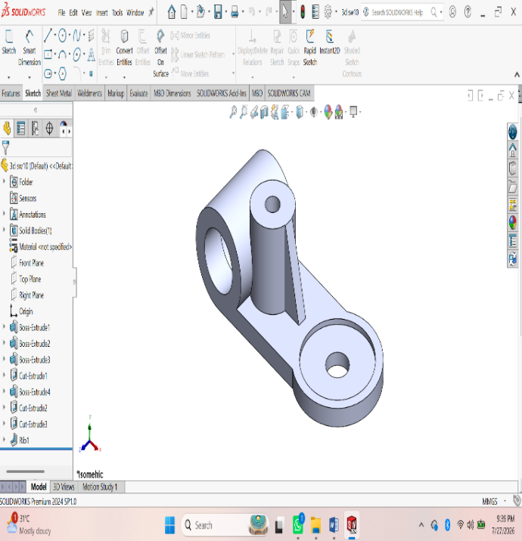Procedure :
- First of all open solidworks software in the laptop or in desktop.
- After opening, click on new the above page will appear in screen.
- After that click on frount view the sketch chuck box will be appear click on it for further step.
- In that page a small rectangular box will appear at above the date and time box, there change the units from ‘MKS’ to ‘MMGS’ units.
- Using ‘Circle’ command draw the diagram with required dimensions by giving alignments to circle.
- After drawing open ‘Extrude’ command and extrude upto required dimensions.
- After that click on top of the extrude part, a sketch box will be appear click on it.
- Again Use Line command and draw the next swept part.
- After drawing, by using ‘swept’ command draw the thread upto required dimensions.
10. After drawing the diagram save it in laptop or in desktop.
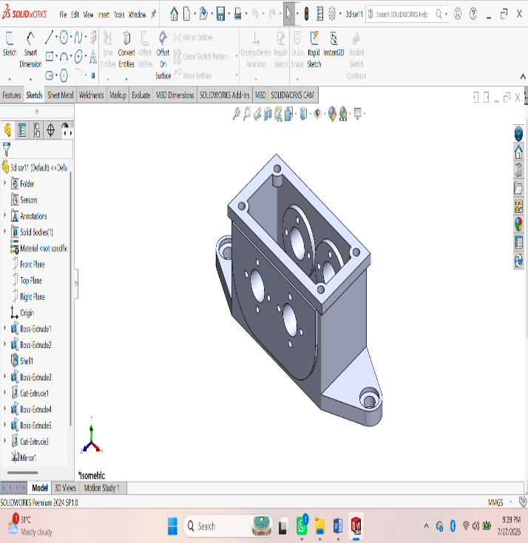
ASSIGNMENT 6:
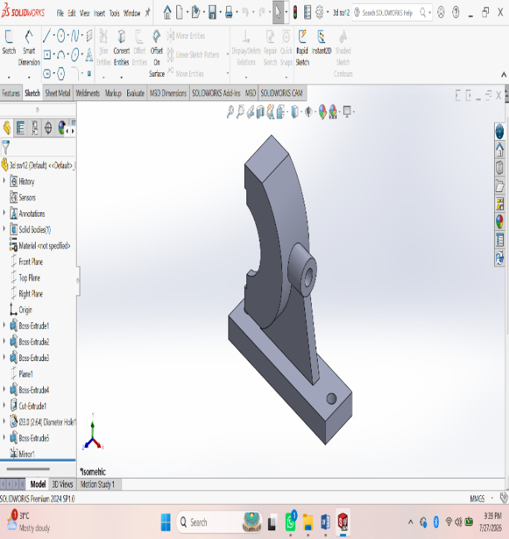Procedure :
- First of all open solidworks software in the laptop or in desktop.
- After opening, click on new the above page will appear in screen.
- After that click on frount view the sketch chuck box will be appear click on it for further step.
- In that page a small rectangular box will appear at above the date and time box, there change the units from ‘MKS’ to ‘MMGS’ units.
- Using ‘Circle’ command draw the diagram with required dimensions by giving alignments to circle.
- After drawing open ‘Extrude’ command and extrude upto required dimensions.
- After that click on top of the extrude part, a sketch box will be appear click on it.
- Again Use Line command and draw the next swept part.
- After drawing, by using ‘swept’ command draw the thread upto required dimensions.
10. After drawing the diagram save it in laptop or in desktop.
ASSESSMENT 7:
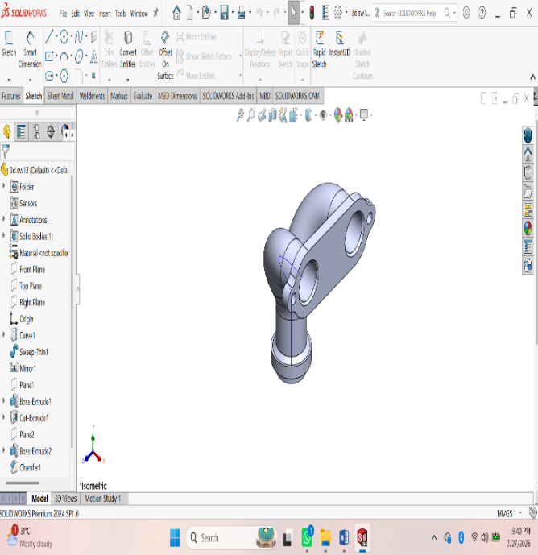
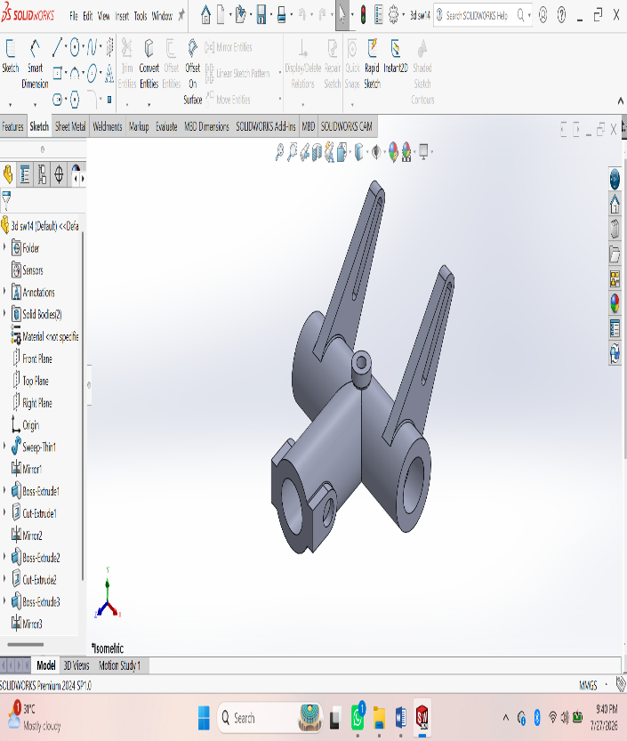Procedure :
- First of all open solidworks software in the laptop or in desktop.
- After opening, click on new the above page will appear in screen.
- After that click on frount view the sketch chuck box will be appear click on it for further step.
- In that page a small rectangular box will appear at above the date and time box, there change the units from ‘MKS’ to ‘MMGS’ units.
- Using ‘Circle’ command draw the diagram with required dimensions by giving alignments to circle.
- After drawing open ‘Extrude’ command and extrude upto required dimensions.
- After that click on top of the extrude part, a sketch box will be appear click on it.
- Again Use Line command and draw the next swept part.
- After drawing, by using ‘swept’ command draw the thread upto required dimensions.
10. After drawing the diagram save it in laptop or in desktop.
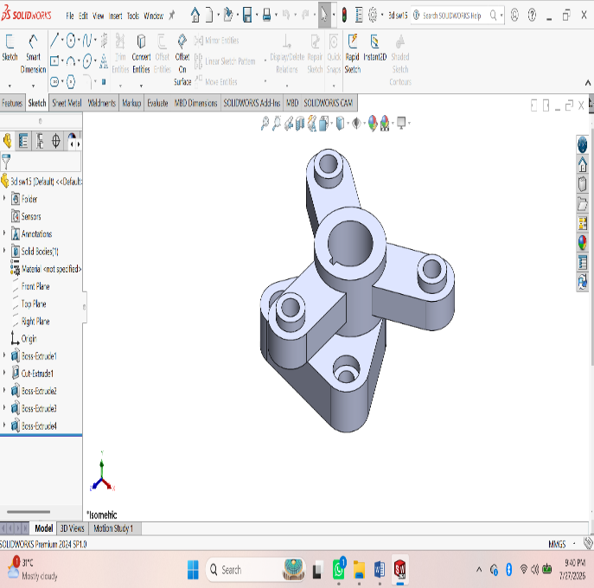
ASSESSMENT 8:
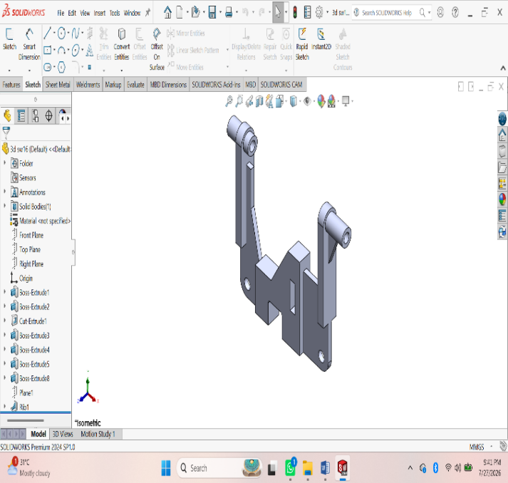Procedure :
- First of all open solidworks software in the laptop or in desktop.
- After opening, click on new the above page will appear in screen.
- After that click on frount view the sketch chuck box will be appear click on it for further step.
- In that page a small rectangular box will appear at above the date and time box, there change the units from ‘MKS’ to ‘MMGS’ units.
- Using ‘Circle’ command draw the diagram with required dimensions by giving alignments to circle.
- After drawing open ‘Extrude’ command and extrude upto required dimensions.
- After that click on top of the extrude part, a sketch box will be appear click on it.
- Again Use Line command and draw the next swept part.
- After drawing, by using ‘swept’ command draw the thread upto required dimensions.
10. After drawing the diagram save it in laptop or in desktop.
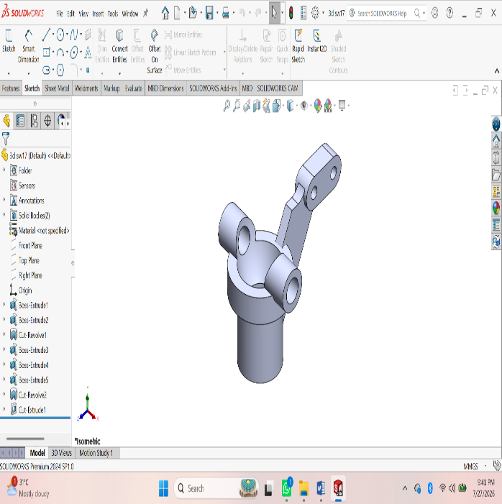
ASSESSMENT 9:
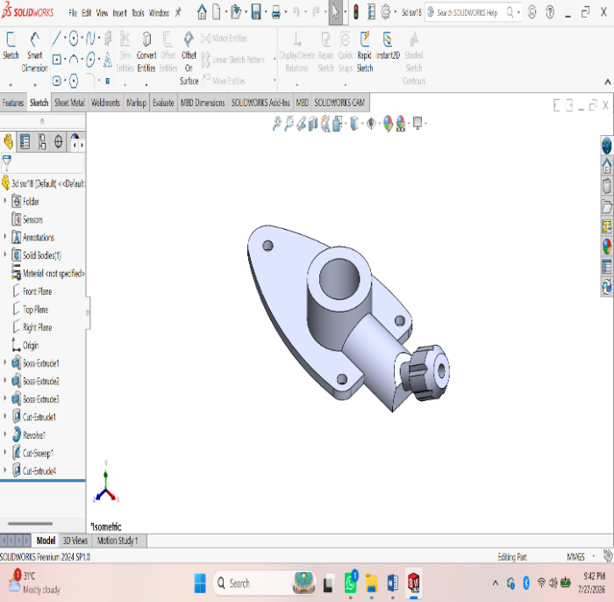Procedure :
- First of all open solidworks software in the laptop or in desktop.
- After opening, click on new the above page will appear in screen.
- After that click on frount view the sketch chuck box will be appear click on it for further step.
- In that page a small rectangular box will appear at above the date and time box, there change the units from ‘MKS’ to ‘MMGS’ units.
- Using ‘Circle’ command draw the diagram with required dimensions by giving alignments to circle.
- After drawing open ‘Extrude’ command and extrude upto required dimensions.
- After that click on top of the extrude part, a sketch box will be appear click on it.
- Again Use Line command and draw the next swept part.
- After drawing, by using ‘swept’ command draw the thread upto required dimensions.
- After drawing the diagram save it in laptop or in desktop.
ASSEMBLY

ASSESSMENT 1:
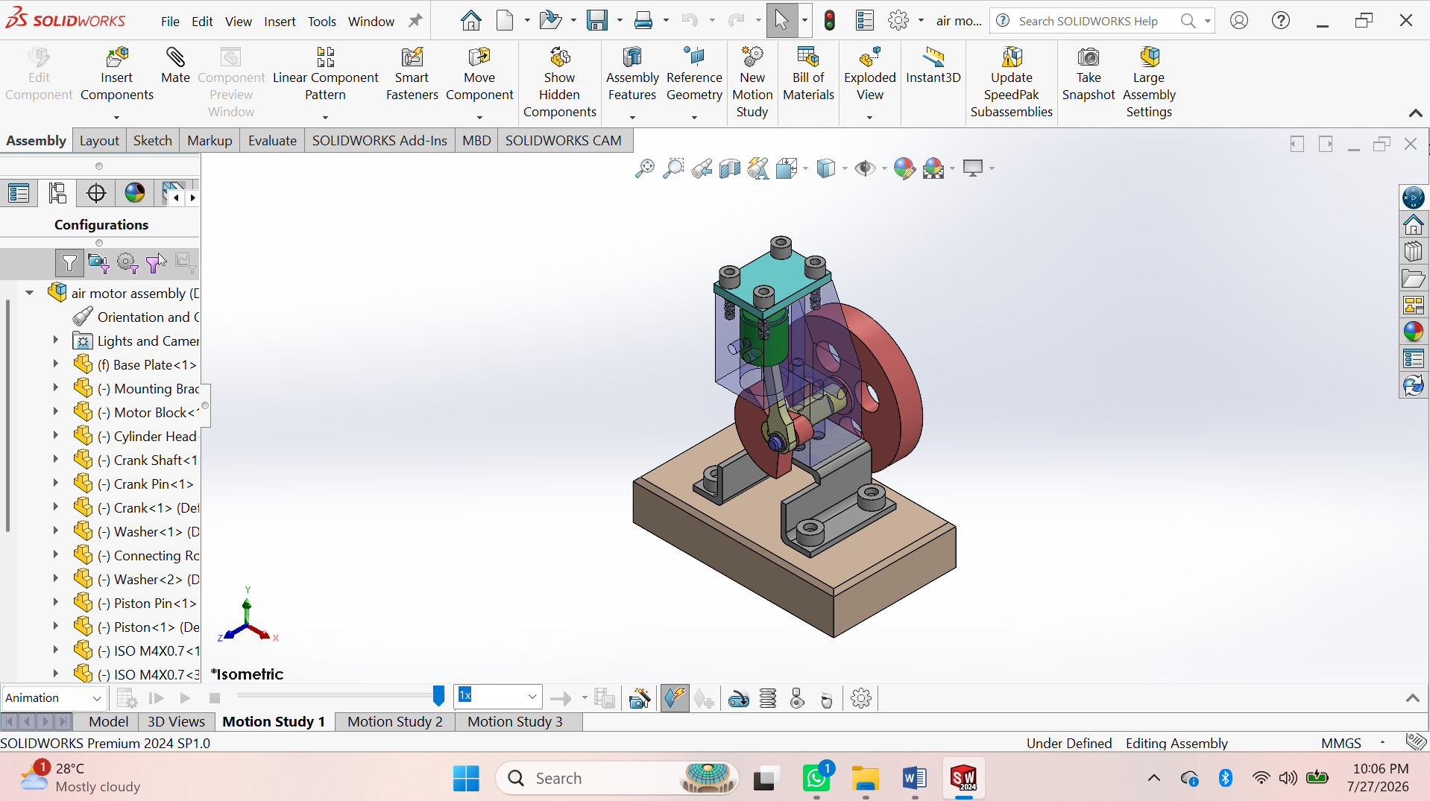
Procedure:
- Open SolidWorks → File > New > Part.
- Create Base Plate using Sketch → Extruded Boss/Base.
- Create Mounting Bracket using Sketch → Extrude → Cut holes.
- Create Motor Block using Extrude → Extruded Cut → Hole Wizard.
- Create Cylinder Head using Extrude → Hole Wizard.
- Create Flywheel using Extrude → Extruded Cut → Circular Pattern.
- Create Crankshaft using Revolved Boss/Base.
- Create Crank using Extruded Boss/Base.
- Create Connecting Rod using Extrude → Hole Wizard.
- Create Piston using Extruded Boss/Base → Cut Hole.
- Create Crank Pin using Revolved Boss/Base.
- Create Piston Pin using Revolved Boss/Base.
- Create Washer using Extruded Boss/Base.
- Insert M3 & M4 Screws from the Toolbox.
- Save all parts individually (.SLDPRT).

Assembly
- File > New > Assembly.
- Insert Base Plate and Fix it.
- Insert Mounting Bracket → Apply Coincident and Concentric Mates.
- Insert Motor Block → Apply Mates.
- Insert Cylinder Head → Apply Mates.
- Insert Crankshaft → Apply Concentric Mate.
- Insert Flywheel → Mate with the crankshaft.
- Insert Crank → Mate to the crankshaft.
- Insert Connecting Rod → Mate to the crank pin.
- Insert Piston → Mate to the connecting rod and cylinder.
- Insert Washers and Screws → Mate them in position.
- Check Interference (Evaluate > Interference Detection).
- Run Motion Study to verify the piston and flywheel movement.
- Save the Assembly (.SLDASM).
- Create the Assembly Drawing with BOM, Balloons, and Dimensions.

ASSIGNMENT 2:

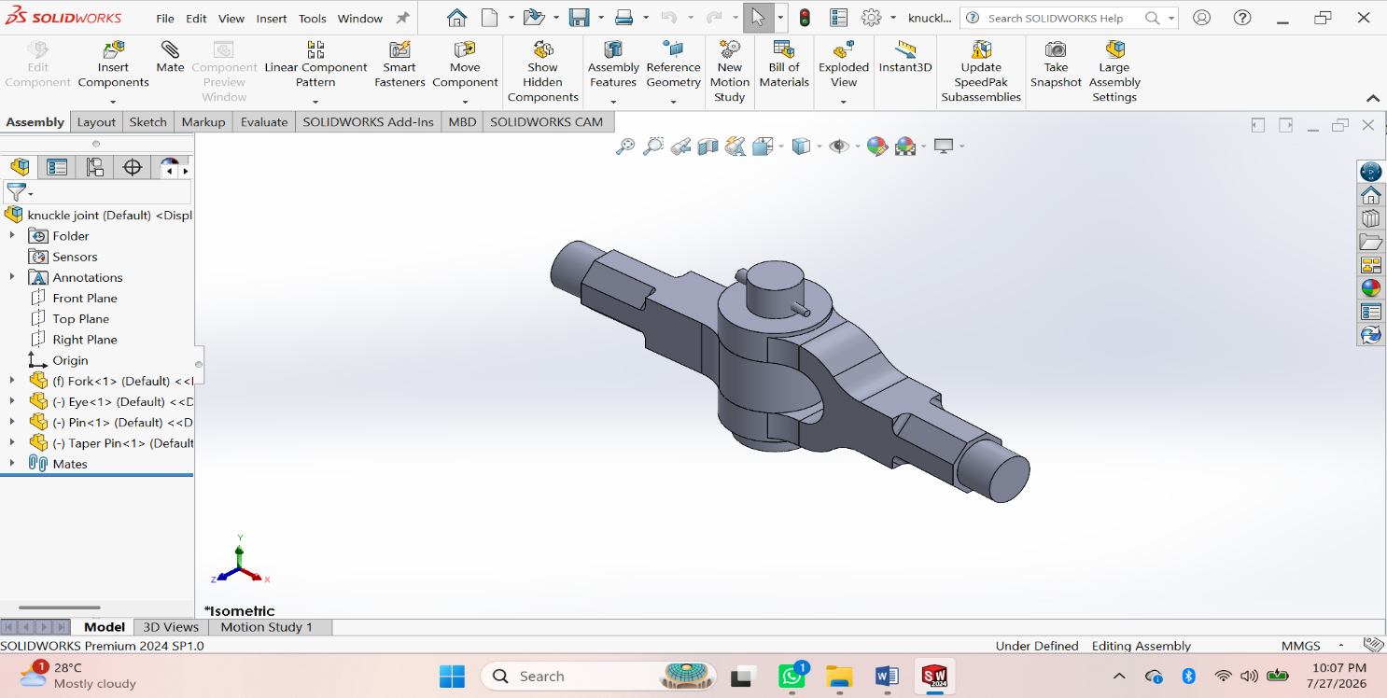
Procedure:
- Create Fork – Sketch → Extruded Boss/Base → Extruded Cut → Fillet → Save.
- Create Eye – Sketch → Extruded Boss/Base → Hole → Fillet → Save.
- Create Pin – Sketch → Revolved Boss/Base → Taper → Save.
- Create Collar – Sketch → Extruded Boss/Base → Taper → Save.
- Create Taper Pin – Sketch → Revolved Boss/Base → Save.
Assembly
- Create New Assembly – Insert Fork and Fix it.
- Insert Eye – Apply Concentric and Coincident Mates.
- Insert Pin – Apply Concentric Mate.
- Insert Collar – Apply Concentric Mate.
- Insert Taper Pin – Apply Concentric and Coincident Mates.
- Check Interference – Evaluate → Interference Detection.
- Save Assembly and create the Assembly Drawing with BOM and Balloons.

ASSESSMENT 3:

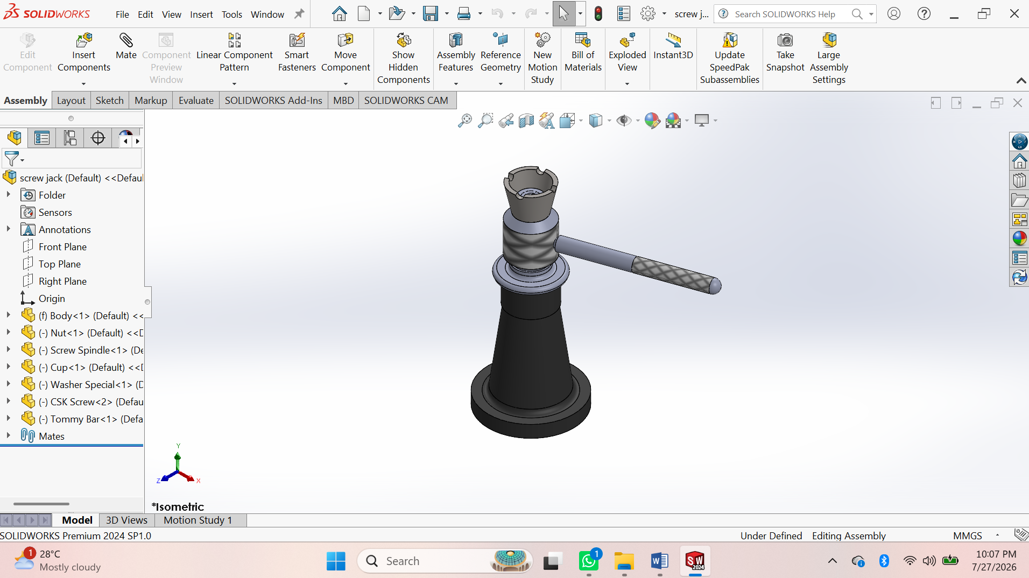
Procedure
- Create Body – Sketch → Revolved Boss/Base → Extruded Cut → Fillet → Save.
- Create Nut – Sketch → Revolved Boss/Base → Hole → Save.
- Create Screw Spindle – Sketch → Revolved Boss/Base → Helix & Thread → Knurl → Save.
- Create Cup – Sketch → Revolved Boss/Base → Extruded Cut → Save.
- Create Special Washer – Sketch → Revolved Boss/Base → Save.
- Create CSK Screw – Sketch → Revolved Boss/Base → Thread → Save.
- Create Tommy Bar – Sketch → Extruded Boss/Base → Chamfer → Save.
Assembly
- Create New Assembly – Insert Body and Fix it.
- Insert Nut – Apply Concentric and Coincident Mates.
- Insert Screw Spindle – Apply Concentric Mate.
- Insert Cup – Apply Concentric Mate.
- Insert Special Washer – Apply Concentric Mate.
- Insert CSK Screw – Apply Concentric and Coincident Mates.
- Insert Tommy Bar – Apply Concentric Mate.
- Check Interference – Evaluate → Interference Detection.
- Save Assembly and create the Assembly Drawing (BOM & Balloons).

ASSESSMENT 4:

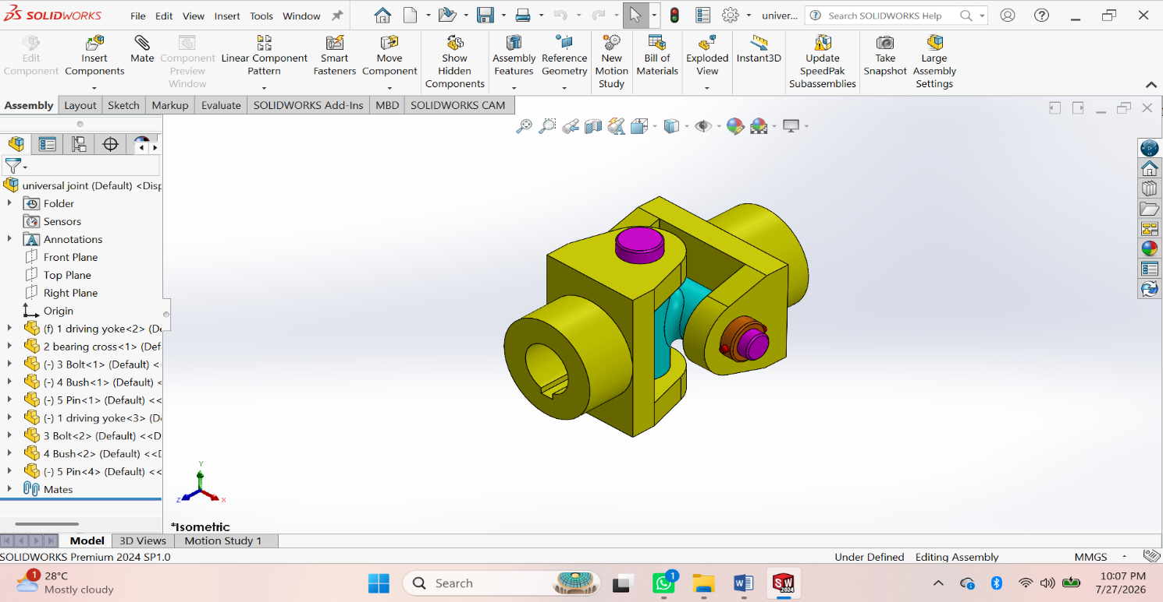
Procedure
• Create Driving Yoke – Sketch → Extruded Boss/Base → Extruded Cut → Hole → Fillet → Save.
• Create Bearing Cross – Sketch → Extruded Boss/Base → Revolved Boss/Base → Hole → Save.
• Create Bolt – Sketch → Revolved Boss/Base → Chamfer → Save.
• Create Bush – Sketch → Revolved Boss/Base → Extruded Cut → Save.
• Create Pin – Sketch → Extruded Boss/Base → Chamfer → Save.
• Create Driven Yoke – Sketch → Extruded Boss/Base → Extruded Cut → Hole → Fillet → Save.
Assembly
• Create New Assembly – Insert Driving Yoke and Fix it.
• Insert Bearing Cross – Apply Concentric and Coincident Mates.
• Insert Driven Yoke – Apply Concentric Mate.
• Insert Bushes – Apply Concentric Mate.
• Insert Pins and Bolts – Apply Concentric and Coincident Mates.
• Check Interference – Evaluate → Interference Detection.
Save Assembly and create the Assembly Drawing (BOM & Balloon

ASSESSMENT 5:

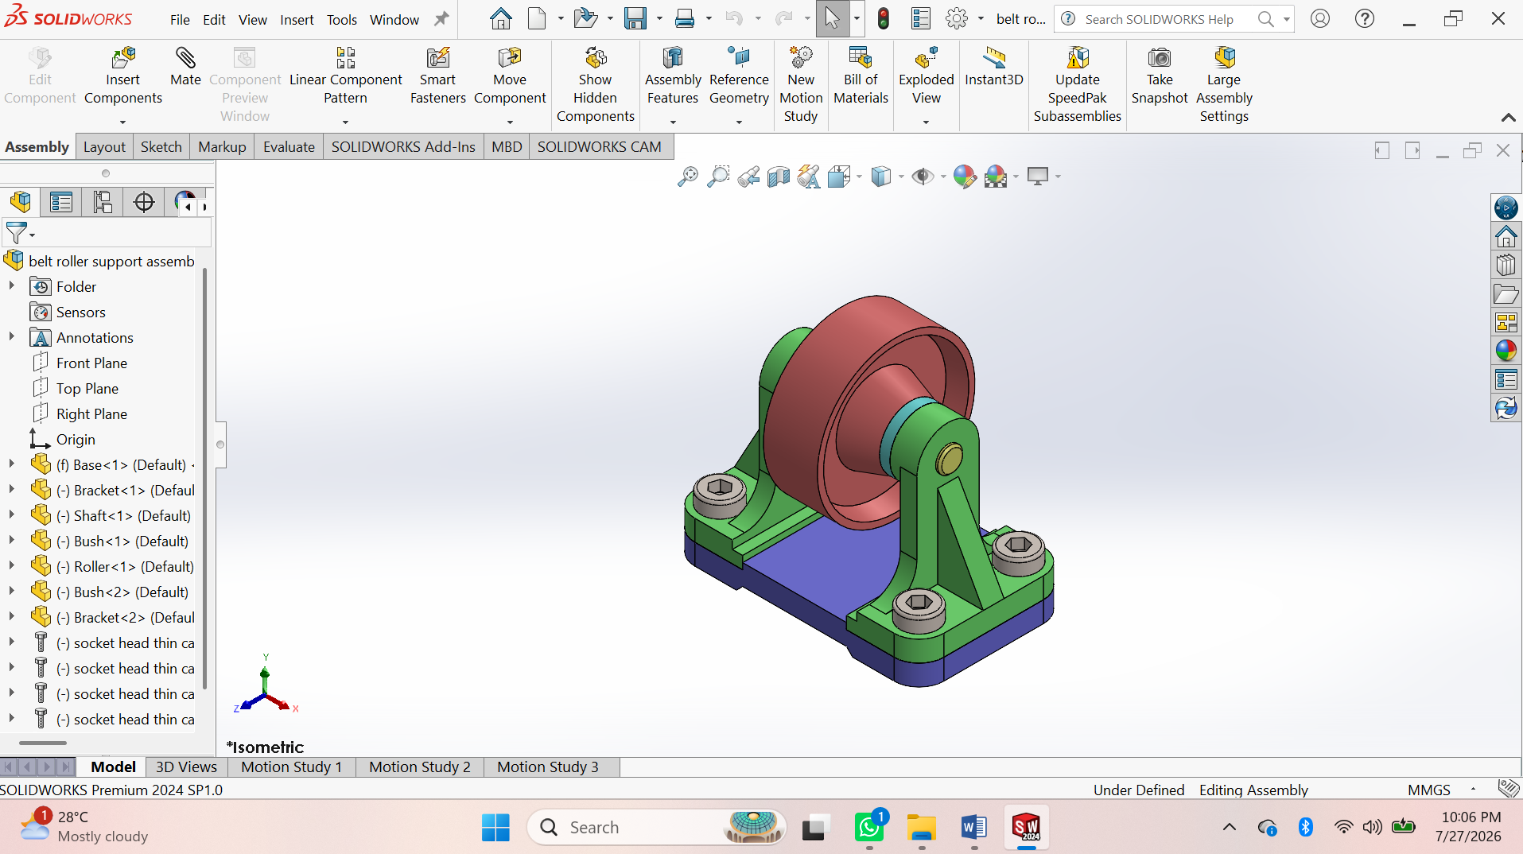
Procedure
• Create Driving Yoke – Sketch → Extruded Boss/Base → Extruded Cut → Hole → Fillet → Save.
• Create Bearing Cross – Sketch → Extruded Boss/Base → Revolved Boss/Base → Hole → Save.
• Create Bolt – Sketch → Revolved Boss/Base → Chamfer → Save.
• Create Bush – Sketch → Revolved Boss/Base → Extruded Cut → Save.
• Create Pin – Sketch → Extruded Boss/Base → Chamfer → Save.
• Create Driven Yoke – Sketch → Extruded Boss/Base → Extruded Cut → Hole → Fillet → Save.

Assembly
• Create New Assembly – Insert Driving Yoke and Fix it.
• Insert Bearing Cross – Apply Concentric and Coincident Mates.
• Insert Driven Yoke – Apply Concentric Mate.
• Insert Bushes – Apply Concentric Mate.
• Insert Pins and Bolts – Apply Concentric and Coincident Mates.
• Check Interference – Evaluate → Interference Detection.
• Save Assembly and create the Assembly Drawing (BOM & Balloon

SHEET METAL

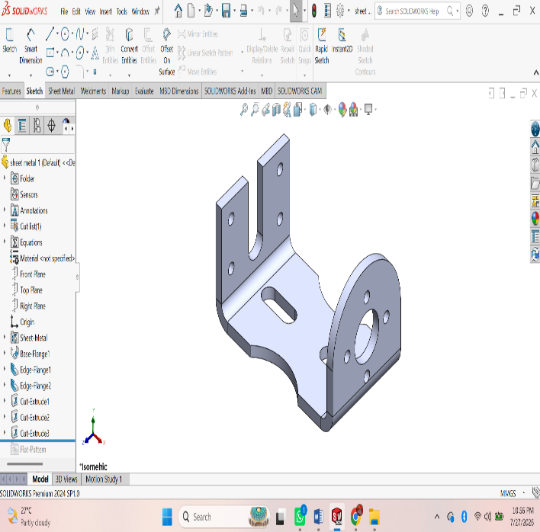
ASSESSMENT 1:

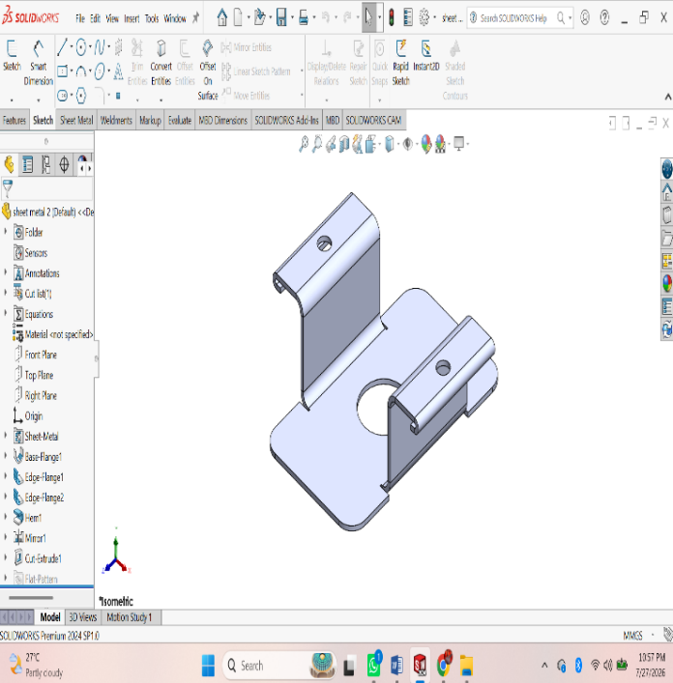

Procedure
• File → New → Part.
• Select the Sheet Metal tab.
• Sketch the base profile on a plane.
• Click Base Flange/Tab and set the sheet thickness.
• Use Edge Flange to create side flanges.
• Use Miter Flange for corner flanges (if required).
• Use Hem to fold sharp edges (optional).
• Use Sketched Bend for custom bends.
• Use Jog to create offset bends (if required).
• Create holes using Hole Wizard or Extruded Cut.
• Add Corner Trim/Corner Relief if needed.
• Apply Fillet or Chamfer to edges.
• Click Flatten to generate the flat pattern.
• Save the part (.SLDPRT).
• Create the drawing and insert the Flat Pattern View with dimensions.

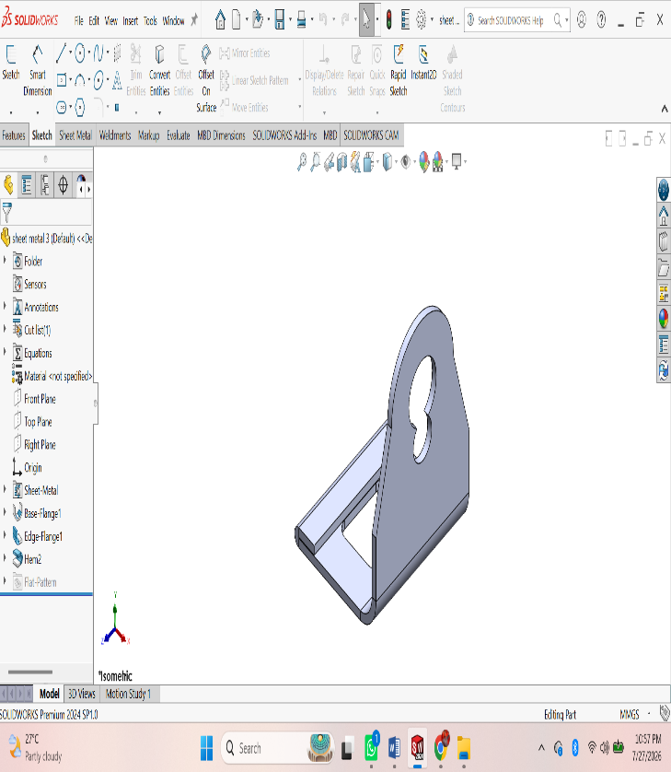
ASSESSMENT 2:
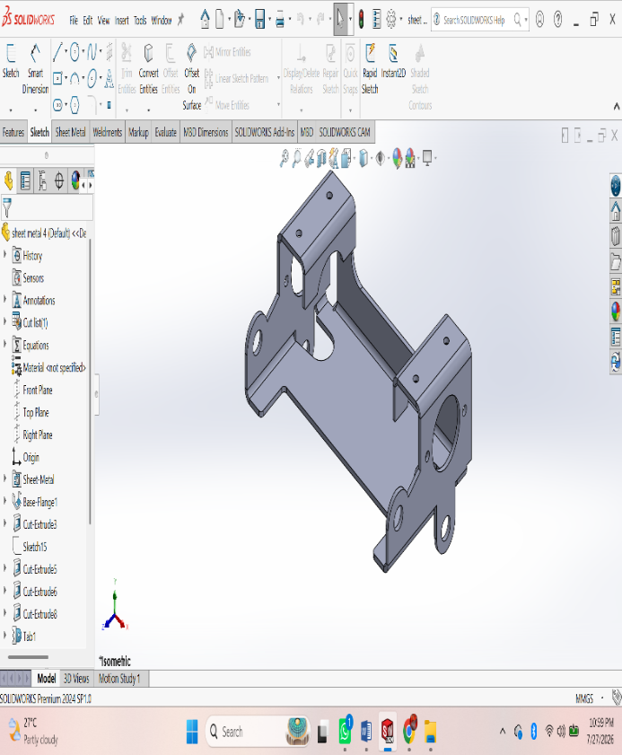
Procedure
• File → New → Part.
• Select the Sheet Metal tab.
• Sketch the base profile on a plane.
• Click Base Flange/Tab and set the sheet thickness.
• Use Edge Flange to create side flanges.
• Use Miter Flange for corner flanges (if required).
• Use Hem to fold sharp edges (optional).
• Use Sketched Bend for custom bends.
• Use Jog to create offset bends (if required).
• Create holes using Hole Wizard or Extruded Cut.
• Add Corner Trim/Corner Relief if needed.
• Apply Fillet or Chamfer to edges.
• Click Flatten to generate the flat pattern.
• Save the part (.SLDPRT).
• Create the drawing and insert the Flat Pattern View with dimensions.

ASSESSMENT 3:

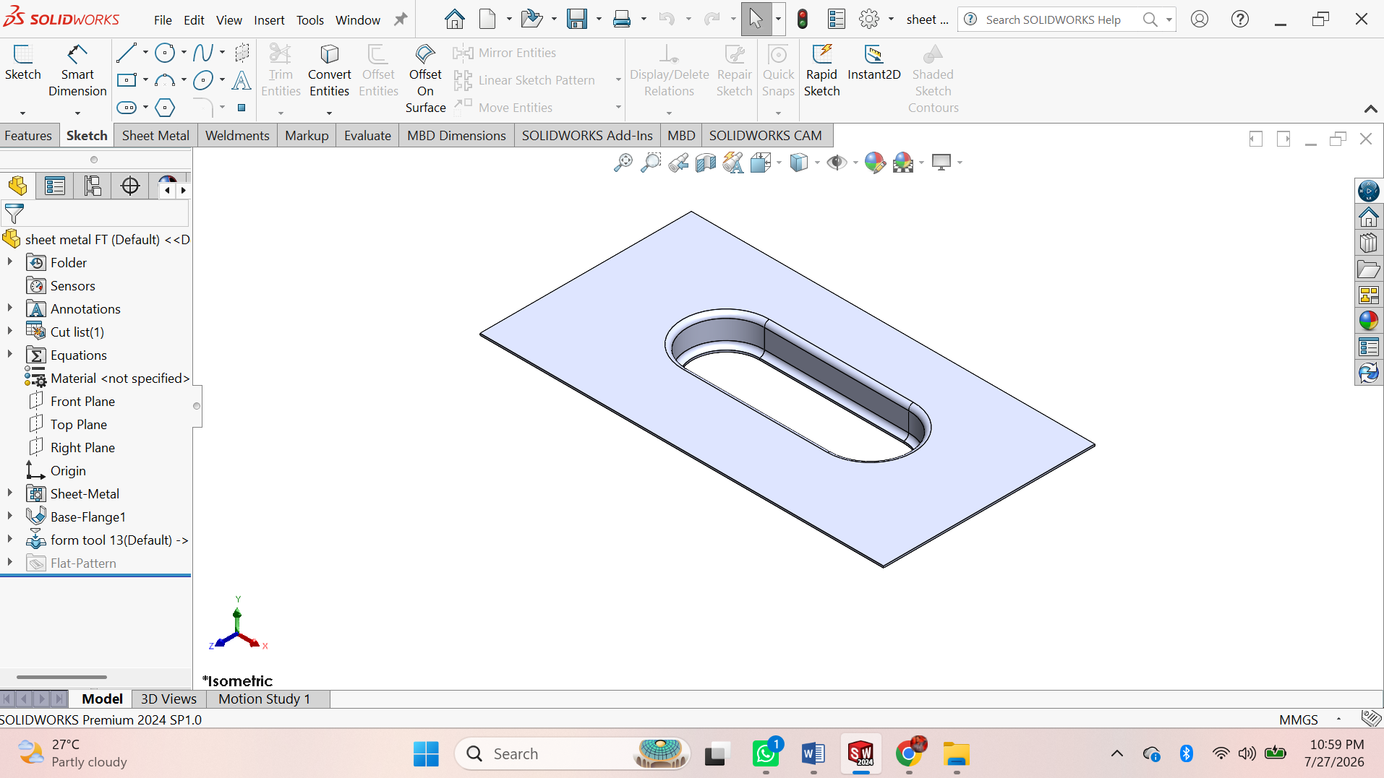
Procedure
• File → New → Part.
• Select the Sheet Metal tab.
• Sketch the base profile on a plane.
• Click Base Flange/Tab and set the sheet thickness.
• Use Edge Flange to create side flanges.
• Use Miter Flange for corner flanges (if required).
• Use Hem to fold sharp edges (optional).
• Use Sketched Bend for custom bends.
• Use Jog to create offset bends (if required).
• Create holes using Hole Wizard or Extruded Cut.
• Add Corner Trim/Corner Relief if needed.
• Apply Fillet or Chamfer to edges.
• Click Flatten to generate the flat pattern.
• Save the part (.SLDPRT).
• Create the drawing and insert the Flat Pattern View with dimensions.

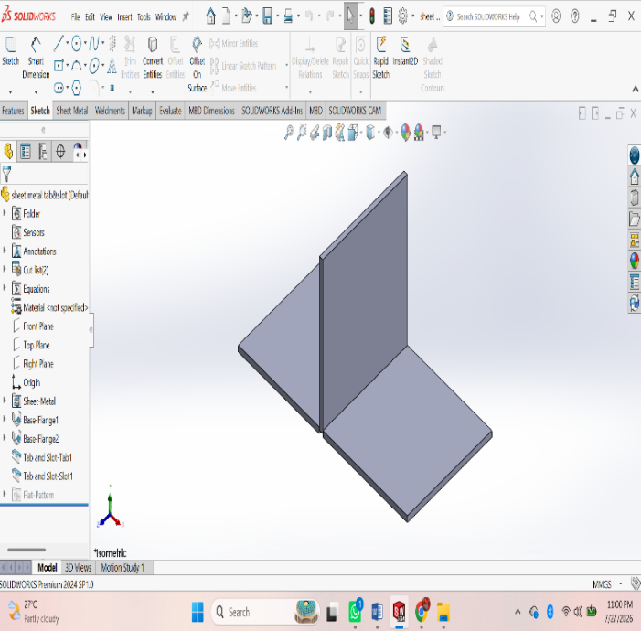
ASSESSMENT 4:

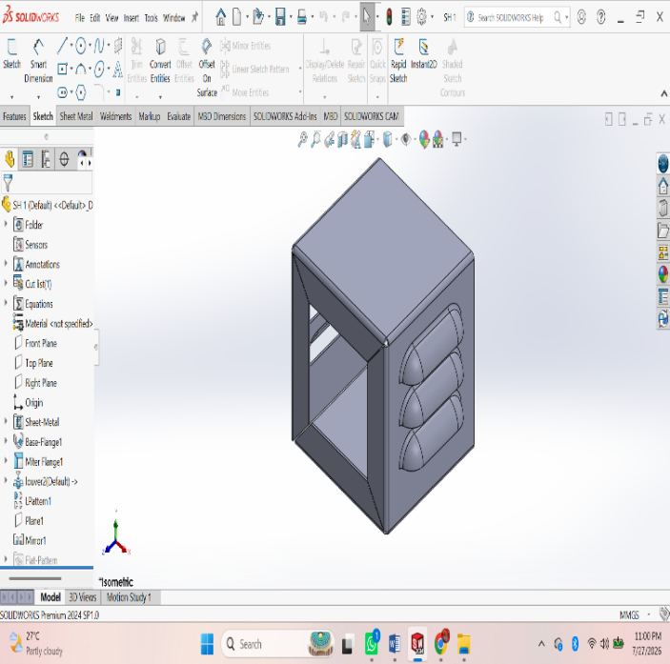
Procedure
• File → New → Part.
• Select the Sheet Metal tab.
• Sketch the base profile on a plane.
• Click Base Flange/Tab and set the sheet thickness.
• Use Edge Flange to create side flanges.
• Use Miter Flange for corner flanges (if required).
• Use Hem to fold sharp edges (optional).
• Use Sketched Bend for custom bends.
• Use Jog to create offset bends (if required).
• Create holes using Hole Wizard or Extruded Cut.
• Add Corner Trim/Corner Relief if needed.
• Apply Fillet or Chamfer to edges.
• Click Flatten to generate the flat pattern.
• Save the part (.SLDPRT).
• Create the drawing and insert the Flat Pattern View with dimensions.

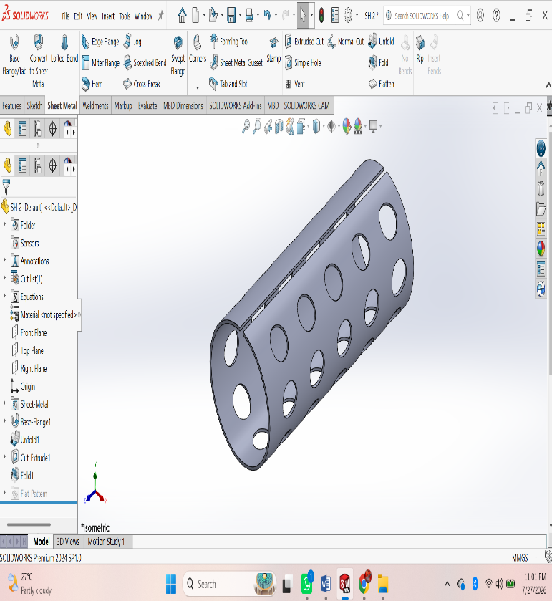
ASSESSMENT 5:
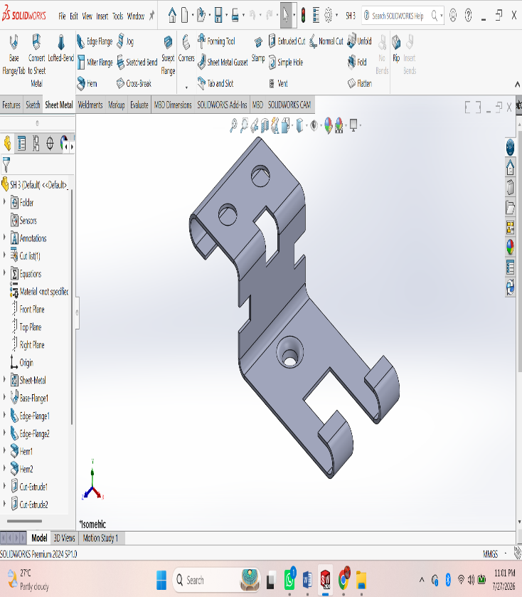
Procedure
• File → New → Part.
• Select the Sheet Metal tab.
• Sketch the base profile on a plane.
• Click Base Flange/Tab and set the sheet thickness.
• Use Edge Flange to create side flanges.
• Use Miter Flange for corner flanges (if required).
• Use Hem to fold sharp edges (optional).
• Use Sketched Bend for custom bends.
• Use Jog to create offset bends (if required).
• Create holes using Hole Wizard or Extruded Cut.
• Add Corner Trim/Corner Relief if needed.
• Apply Fillet or Chamfer to edges.
• Click Flatten to generate the flat pattern.
• Save the part (.SLDPRT).
• Create the drawing and insert the Flat Pattern View with dimensions.

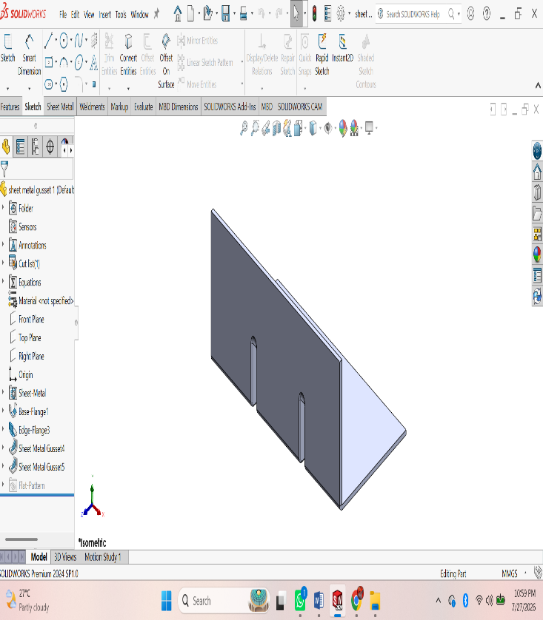
ASSESSMENT 6:

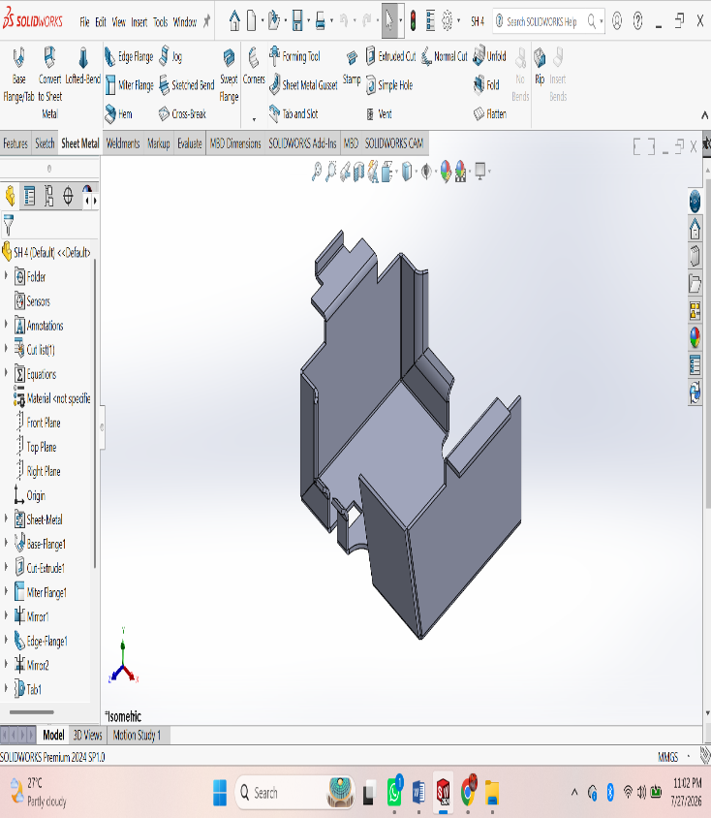

Procedure
• File → New → Part.
• Select the Sheet Metal tab.
• Sketch the base profile on a plane.
• Click Base Flange/Tab and set the sheet thickness.
• Use Edge Flange to create side flanges.
• Use Miter Flange for corner flanges (if required).
• Use Hem to fold sharp edges (optional).
• Use Sketched Bend for custom bends.
• Use Jog to create offset bends (if required).
• Create holes using Hole Wizard or Extruded Cut.
• Add Corner Trim/Corner Relief if needed.
• Apply Fillet or Chamfer to edges.
• Click Flatten to generate the flat pattern.
• Save the part (.SLDPRT).
• Create the drawing and insert the Flat Pattern View with dimensions.

ASSESSMENT 7:

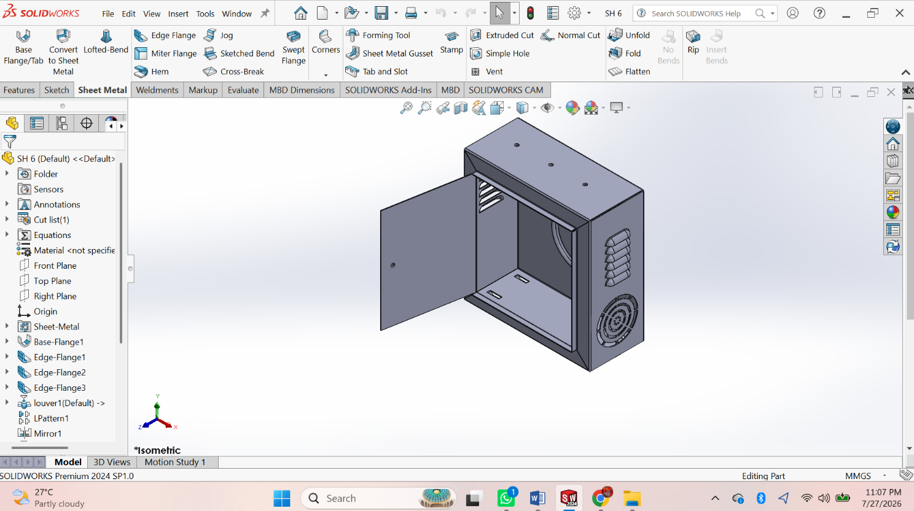
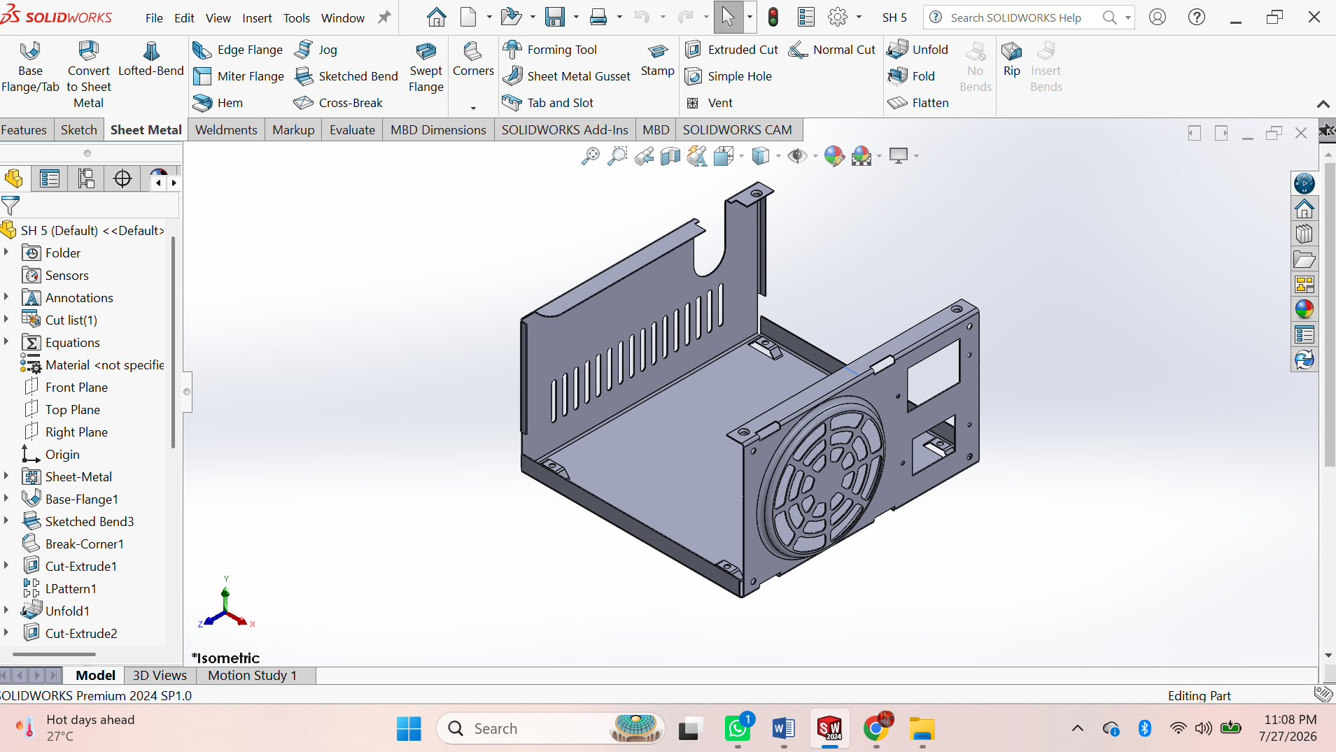

WELDMENTS

ASSESSMENT 1:
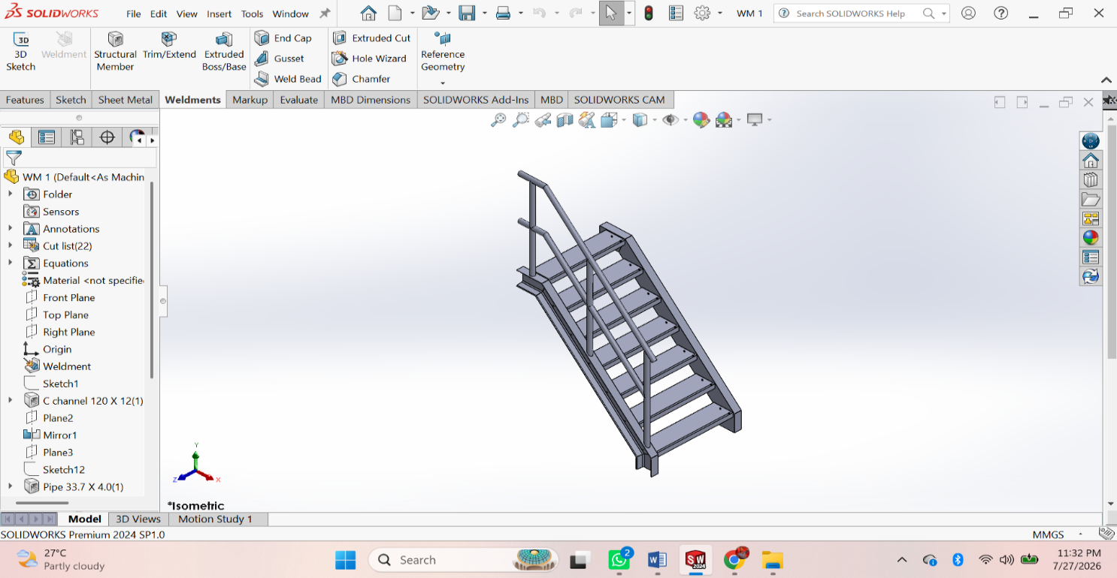
Procedure
• File → New → Part.
• Enable the Weldments tab.
• Create a 2D/3D Sketch for the frame layout.
• Click Structural Member and select the standard, type, and size.
• Apply the structural member to the sketch.
• Use Trim/Extend to trim intersecting members.
• Add Gusset where required.
• Add End Cap to open tube ends (optional).
• Use Weld Bead to create welds (if required).
• Create holes or cuts using Extruded Cut.
• Apply Fillet or Chamfer if needed.
• Check the Cut List and update it.
• Save the weldment part (.SLDPRT).
• Create the drawing and insert the Cut List with dimensions.

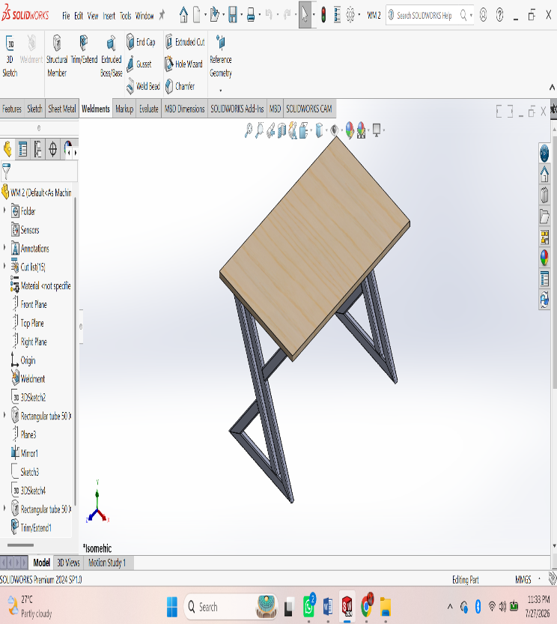
ASSESSMENT 2:
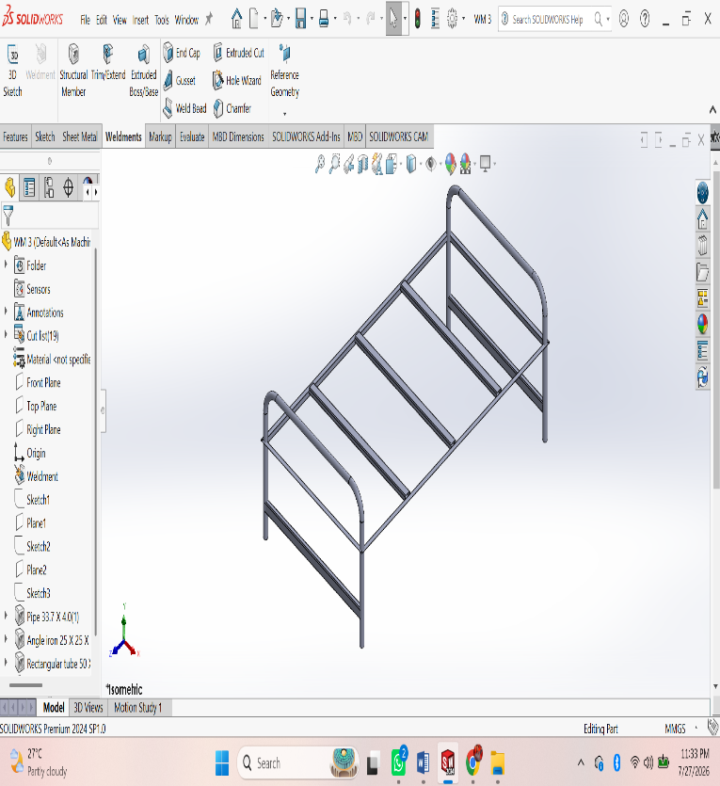
Procedure
• File → New → Part.
• Enable the Weldments tab.
• Create a 2D/3D Sketch for the frame layout.
• Click Structural Member and select the standard, type, and size.
• Apply the structural member to the sketch.
• Use Trim/Extend to trim intersecting members.
• Add Gusset where required.
• Add End Cap to open tube ends (optional).
• Use Weld Bead to create welds (if required).
• Create holes or cuts using Extruded Cut.
• Apply Fillet or Chamfer if needed.
• Check the Cut List and update it.
• Save the weldment part (.SLDPRT).
• Create the drawing and insert the Cut List with dimensions.

PROJECT 1

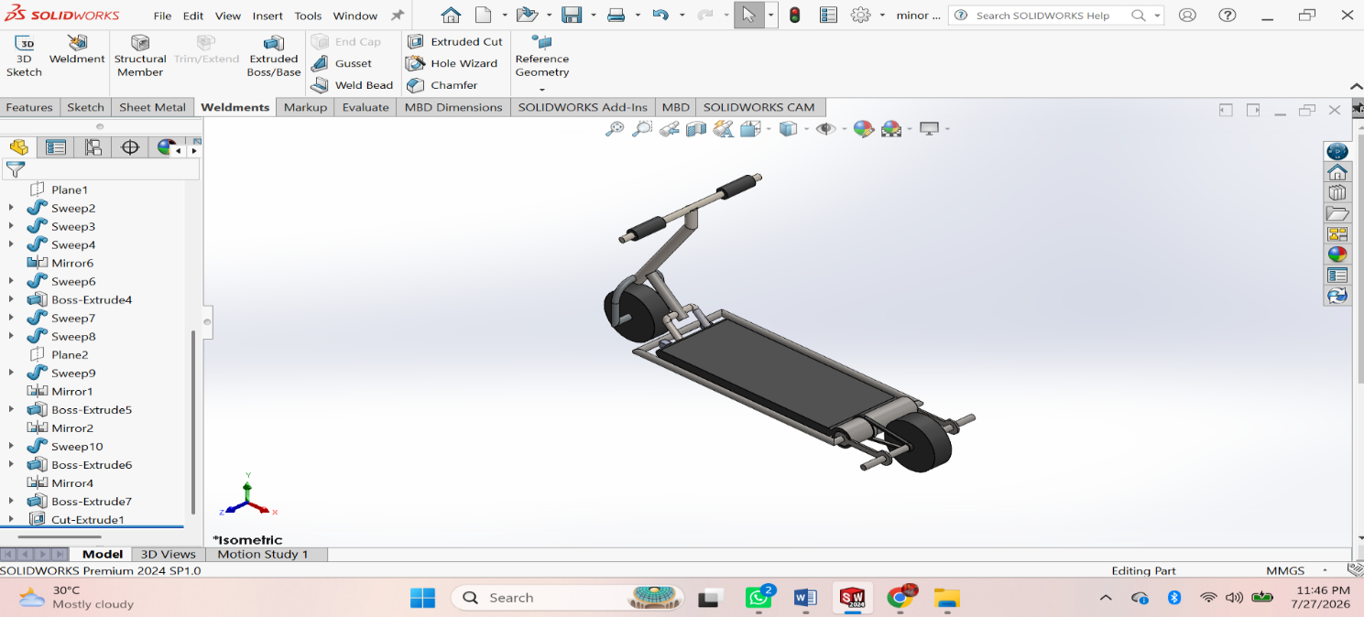

Procedure
- First of all open solidworks software in the laptop or in desktop.
- After opening, click on new the above page will appear in screen.
- After that click on frount view the sketch chuck box will be appear click on it for further step.
- In that page a small rectangular box will appear at above the date and time box, there change the units from ‘MKS’ to ‘MMGS’ units.
- Using ‘Circle’ command draw the diagram with required dimensions by giving alignments to circle.
- After drawing open ‘Extrude’ command and extrude upto required dimensions.
- After that click on top of the extrude part, a sketch box will be appear click on it.
- Again Use Line command and draw the next swept part.
- After drawing, by using ‘swept’ command draw the thread upto required dimensions.
10. After drawing the diagram save it in laptop or in desktop.
PROJECT 2
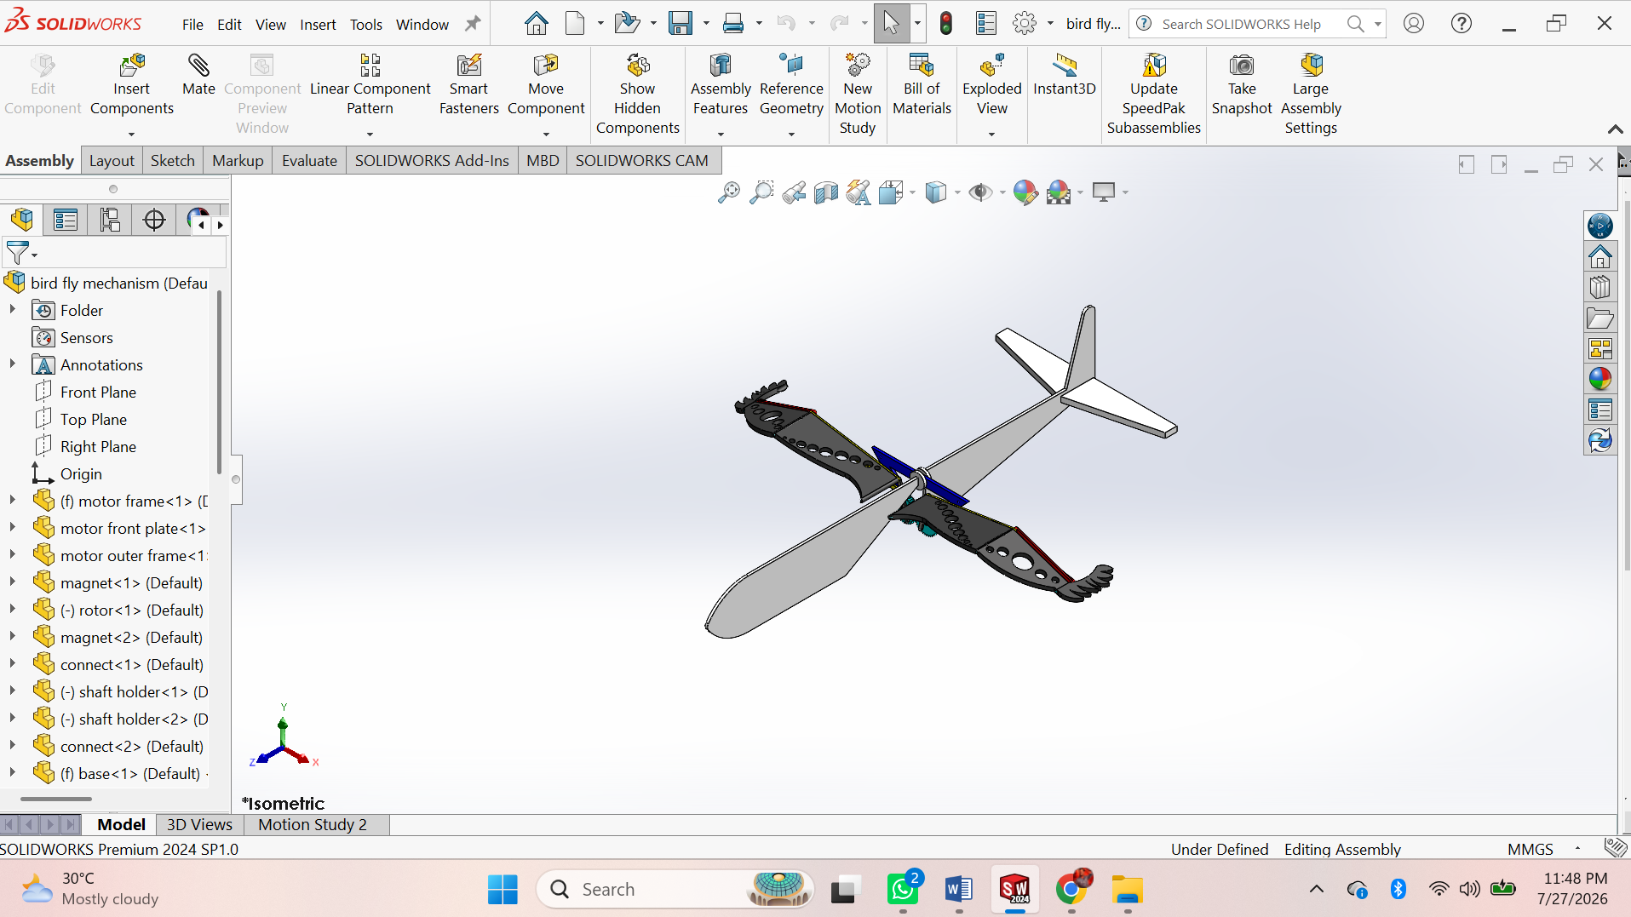
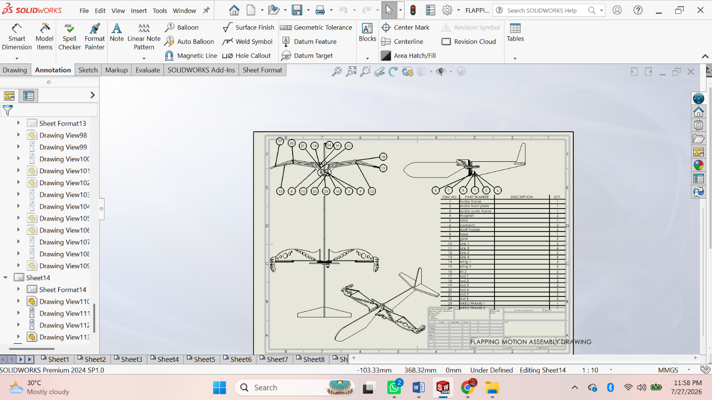
Procedure
• Create all Parts – Base, Frame, Crank, Shaft, Connecting Rod, Wing Link, Wing, Pins, Bushes, and Fasteners.
• Save each part as .SLDPRT.

Assembly

• File → New → Assembly.
• Insert Base and Fix it.
• Insert Frame – Apply Coincident Mate.
• Insert Shaft – Apply Concentric Mate.
• Insert Crank – Apply Concentric and Coincident Mates.
• Insert Connecting Rod – Apply Concentric Mate.
• Insert Wing Link – Apply Concentric Mate.
• Insert Left and Right Wings – Apply Hinge (Concentric) Mates.
• Insert Pins, Bushes, and Fasteners – Apply Concentric and Coincident Mates.
• Apply Mechanical Mates (Hinge/Limit Angle/Gear Mate if required).
• Check Interference – Evaluate → Interference Detection.
• Create Motion Study – Add Rotary Motor to the crankshaft and run the simulation.
• Save the Assembly (.SLDASM) and create the Assembly Drawing with BOM and Balloons.

4.STUDENT FEEDBACK
I am very thankful for giving me this opportunity to the SURE Trust. I enjoyed the course and learned a lot from it. The content is well organized and focused on both theory and practical situations. I particularly enjoyed the teaching style of trainer who have teach this course to us. Because, he teach this course in understanding manner. And I learned life skills, how to prepare resume from ‘LST’ Session. I loved it. And ‘EACH ONE PLANT ONE’ program inspires me a lot in SURE Trust. I really thankful to SURE Trust.

5.UNIQUENESS OF THE CROUSE
- Concepts are learnt theoretically and practically.
- Faculty is committed in delivering the course
- Thought provoking assignments will be given
- Preparation of course report, which will help us to refer in the future
- Concentrate on each and every student in the course

6.Concluding Remarks

A lot of experience, knowledge and exposure that I have handy. All disclosures were awaken myself in a boost of self-confidence to face life more challenging now. Practical is a complement to the science or theory learned. I conclude that the SURE Trust training program has provided many benefits to students. I really proud to be a student of SURE Trust

